10th February 2023
Happy Friday! Term 3 has certainly whizzed by. The mornings are now getting brighter and l have seen daffodils poking up in Northdown Park, so longer days and warmer weather is on the way. Enjoy your week off, find time to get out and explore and we look forward seeing you to term 4. Enjoy the newsletter.
Forthcoming Dates
- Monday 20th February - 1st day of Term 4
- Friday 3rd March – World Book Day
- Friday 31st March – Last day of Term 4 1:30 finish
- Monday 17th April - 1st day of Term 5

Safer Internet Week
Today marks the end of Safer Internet Week at St Anthony’s. Across the school this week, we have been learning about the importance of keeping safe online, with a particular focus on online gaming.
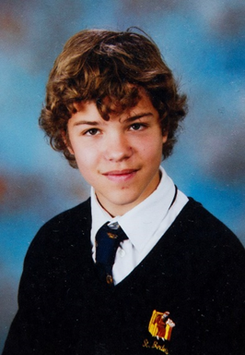
We have focused much of our learning this week on the true-life story of Breck Bednar. Breck was a 14-Year-old boy, who was be-friended by an online Troll whilst gaming online. Things did not end well for Breck when he agreed to meet with the Troll. The story of Breck Bednar is incredibly sad but it has helped us to teach all at St Anthony’s the difference between ‘fake news and true stories’, the importance of talking to someone if we are worried (and who we can talk to) and the difference between ‘good’ and ‘bad’ things about online gaming and the internet.

British Values Recognition Awards
In assembly this week, the first three pupils were awarded their wristbands, for demonstrating British Values. The wristbands were awarded to these pupils by the school council.
Cody C was awarded Rule of Law, for his amazing football support of younger pupils on the primary playground; he is a future PE teacher in the making!
Stanley B in Year 11 was awarded Mutual Respect for going to the aid of an elderly woman, who had fallen over in public.
Blaine G was awarded Mutual Respect for demonstrating throughout the last week in January, kindness and helpfulness towards his peers.
These are excellent achievements, we are very proud of all three young people!
Revamped Reading Room!
The Reading Doctors have redecorated our Reading Hub to enhance the learning environment for our pupils.

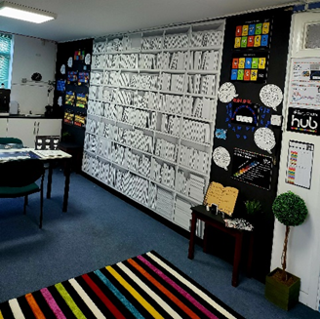
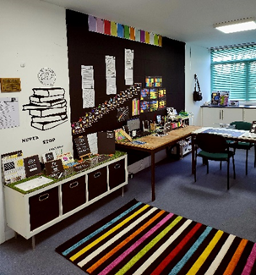
There is now a bookshelf mural where all pupils sign their name once they have graduated from The Reading Doctor Intervention, creating a legacy.

We are hoping that in the future they will be able to come back to visit and locate their signed book on our celebratory wall. This also reflects our mission at St. Anthony’s, to have a no excuses policy in terms of enabling all our pupils to reach a functional reading age.

Dodgeball House Competition
This week the children took part in an Inter-House Dodgeball tournament. Starting with Primary, each house played each other once and then the scores were calculated in order to set up a third place playoff and a Final. This was a very competitive competition.

The Vikings and Romans both won a game each, which meant they had to battle it out against each other for the third spot. Romans went on to be victorious.

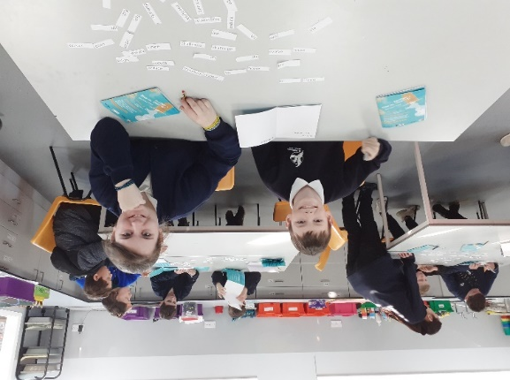
The Saxons and Normans both won two out of the three games and scored seven points each. This meant they were through into a nail biting Final against each other. The Saxons went on to be victorious after a very close match and became the Champions of Primary Dodgeball.

Player of the Tournament – Ashton N
1st Saxons
2nd Normans
3rd Romans
4th Vikings

Next up was the Secondary children. There only ended up being three teams for this – Romans, Saxons and Normans.

The Romans won both of their matches, The Saxons beat the Normans, who gave it their all but unfortunately lost both matches.

There was then an exhilarating final match between The Saxons and The Romans. It could have gone either way, but The Romans edged the win with some fantastic play by the Player of the Tournament – Cody C taking on Taio H in a very tense last man standing finish.
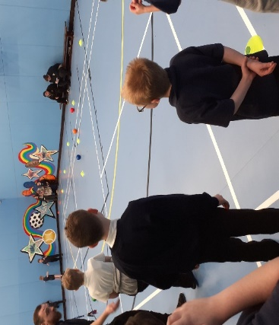

Well done to all of the children involved!

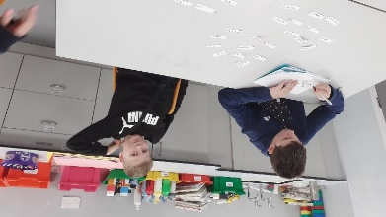
Turner Contemporary Visitors

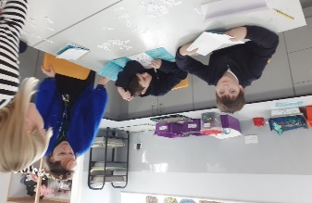
On Wednesday 8th February, we had three art educators from the Turner Contemporary come and do a talk and workshop for this year's
Portfolio competition. This year's competition is called 'Rising' and is all about climate change and the vast quantity of plastic in our oceans. 'Rise up, Clean up' is an organisation set on cleaning up Margate's beaches, protecting our ocean and removing all the rubbish left on the sand and in the sea. Over two years they have removed nearly 1000 bags of litter from Margate's beach!
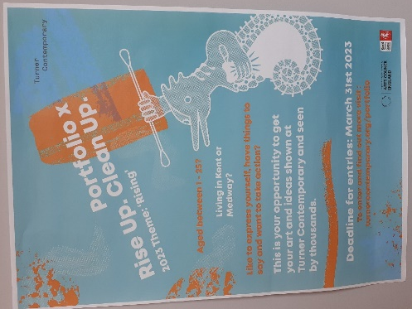
There are 17 new and beautiful murals around Margate, which have been put up to help support the 'Rise up, Clean up' campaign. Today students answered questions, drew, experimented and explored ideas relating to the Portfolio competition theme. In art all KS3 students will be engaging in a project inspired by this theme, so they can submit a piece of artwork for the competition. Students who are nominated will have their artwork displayed in the Turner Contemporary for the summer! There are also lots of prizes and certificates to be handed out to students too.
Attendance
Well done to all the students who have been able to obtain 100% Weekly Attendance throughout Term 3! As a school we are currently sitting at 81.35% which is good, we are still striving to achieve an overall attendance of 85% and we hope with your continued support we can achieve this next term!

Half Term Fun
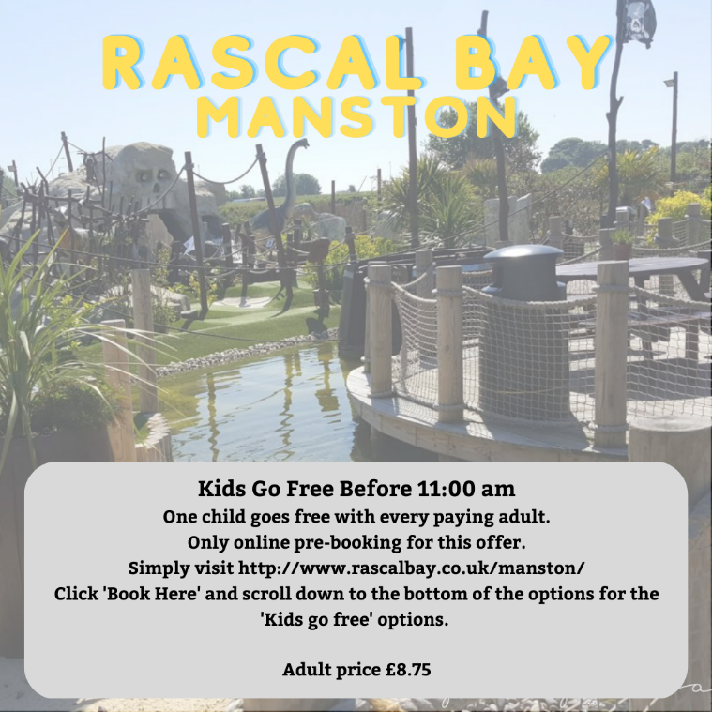
Some of the actives available this February

Discovery Planet – Science Workshops
SPORT FOR FUN –
Saturdays (term time) 9.00 - 10.00 at St Anthony's School. A Saturday morning sports club for children with SEND.
BE ACTIVE -SHORT BREAK - Saturdays (term time) 10.30 - 12.00 at Foreland Fields School
BE ACTIVE -SHORT BREAK - Wednesdays (term time) 4.30 - 6.00 at Foreland Fields School
Please read the PDF letter attached for more information and complete the following referral form to declare interest:
https://forms.office.com/r/EZwuMEZmEd
CLIP N CLIMB - Thursdays Session 1: 4.30-5.30pm Session 2: 5.30-6.30pm.
To book please clink on this link: https://forms.gle/EHYHiAtxWfE3XYDz6
MARGATE YOUTH FC KICKS 4 KIDS - Tuesdays 5.00-5.45 at Margate FC
Inclusive football sessions delivered by Inclusive Sport. To register please visit: https://www.margateyouthfc.co.uk/events/kick-inclusive-football-sessions
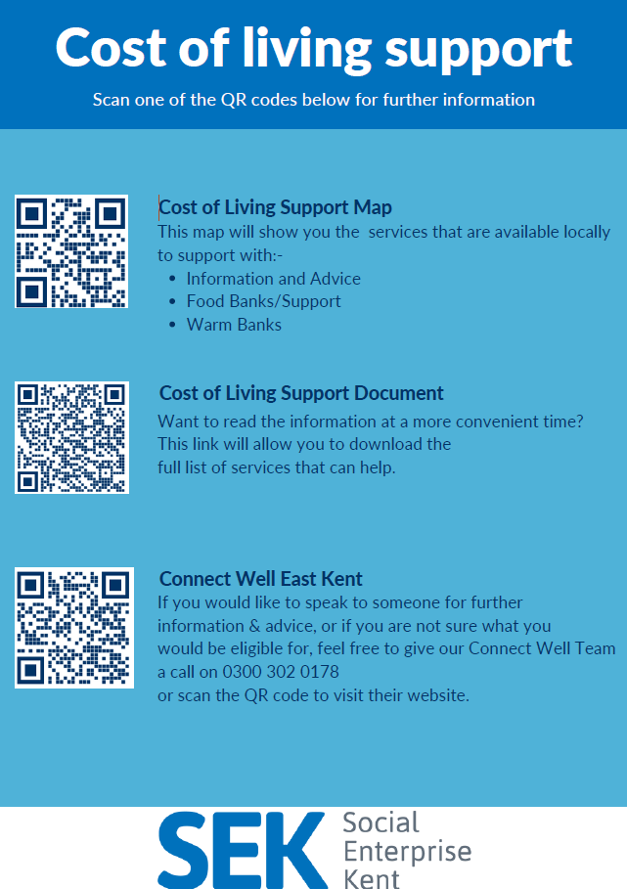
Cost of Living Support
With the pressures of costs around us there is a number of services that can support. If you are having troubles please contact them direct or come and talk with us.
A link below is Thanet councils community hub which can sign post to a range of support functions.
https://www.thanet.gov.uk/info-pages/covidcommunityadvice/
DWP - Outreach sessions for families
Outreach sessions are being held in local venues. Support on hand includes, benefit
advice, childcare choices and cost, finding work, cost of living, housing and any queries that our work coach can support the family with.
Ramsgate – The Priory Children’s Centre, Cannon Rd, Ramsgate CT11 9SQ
Outreach available every Wednesday between 9am to 12noon To book a slot to see our adviser at the Priory Children Centre in Ramsgate please contact
jayne.conroy@dwp.gov.uk

Margate – Six Bells Children Centre, 201 High St, Margate CT9 1WH
Outreach available every Monday between 1pm to 4pm To book a slot to see our adviser at the Six Bells in Margate please contact
philip.raeburn@dwp.gov.uk or anita.taylor@dwp.gov.uk
Royal British Legion - Energy Support
The Royal British Legion, the UK's largest charity dedicated to supporting the Armed Forces community, has today launched a new grant scheme for veterans and their families who are struggling to pay their energy bills. The initiative will provide non-repayable emergency grants of up to £2,400 a year (£200 a month) and is available across the UK.
In general, the Armed Forces community includes those who have served, or are serving, in the Royal Navy, British Army or Royal Air Force, as well as their families, dependants and carers – which can include children, current and former spouses and partners, widows and widowers.
To apply it's worth checking your eligibility on its website or by calling its helpline on 0808 802 8080.
Visit Kent Resilience Hub where you can increase your understanding, find approaches and tools or navigate your way to support and services relating to resilience and emotional wellbeing.
Kooth online support and counselling for 10-25 year olds across Kent and Medway. Offering 1-2-1 counselling, helpful articles, community discussion boards and daily journals.
MindEd is a free educational resource on children and young people's mental health for all adults.

Find out how to tackle hate online and online trolls with internet matters advice guide for what online hate is and how to support your child. Get tools and tips to support your child’s digital wellbeing on Facebook, Instagram and WhatsApp.
Call NSPCC on 0808 800 5000 if you’re worried about the safety of a child. Or call the police on 999 if you think a child is in immediate danger.

Mind's Action for Children around self esteem and helping your child. Parents with Confidence help your child to emotionally regulate.
Free and confidential advice from Family Lives on 0808 800 2222 if you’re finding it hard at home with your child and are struggling to cope.
Young Minds have a parent’s helpline, information and resources.
www.myfamilycoach.com
We’re Here to Help. We all have times when we need some parenting support. With My Family Coach, you get all the help you need.
Our help and ideas cover every‌ ‌stage‌ ‌of‌ ‌your‌ ‌child’s‌ ‌development. We’ll support you through the tough times, inspire you with new ideas, and share practical tips to make parenting that little bit easier.

