**15th March 2024**

It has been another couple of busy weeks at St Anthony’s.  
Last Thursday we celebrated World Book Day which saw pupils and staff dressed up as characters from a range of books.  
Pegwell Class had a ferocious Wolf terrifying the Three Little Pigs, Jessica Fletcher from Murder She Wrote was solving crimes and Louisa Class were characters from Charlie and the Chocolate Factory.

The kitchen staff also got involved with a special menu that included Hungary caterpillar Salad, Horrid Henry Hot Dogs with Gruffalo Tusks and Cat in the Hat Bowtie Pasta.

This week has been science week and Tuesday we had a Travelling Food Roadshow which captured the pupils interest in a Ready Steady Cook manner.  
Year 11s are working hard on achieving their qualifications and this week sat their maths exams.   
Today is Red Nose Day - fun and excitement never stops at St Anthony’s!

The next two weeks is the Great Britain Clean Up, so with the weather improving get out and clean up your neighbourhood.  Pupils will be out cleaning areas as we have pledged to collect over thirty sacks of rubbish.  
 ***Robert Page, Head Teacher***  
**Dates for the diary**

* **Thursday 28th March –** Last day of Term 4 **1:30pm Finish**
* **Monday 15th April –** First day of Term 5
* **Monday 6th May –** Bank Holiday
* **Tuesday 7th May –** INSET DAY

**British Values**

* **Democracy** - have the right to have your voice heard
* **Individual Liberty** - Promote freedom of choice
* **Rule of Law** - The importance of law and rules
* 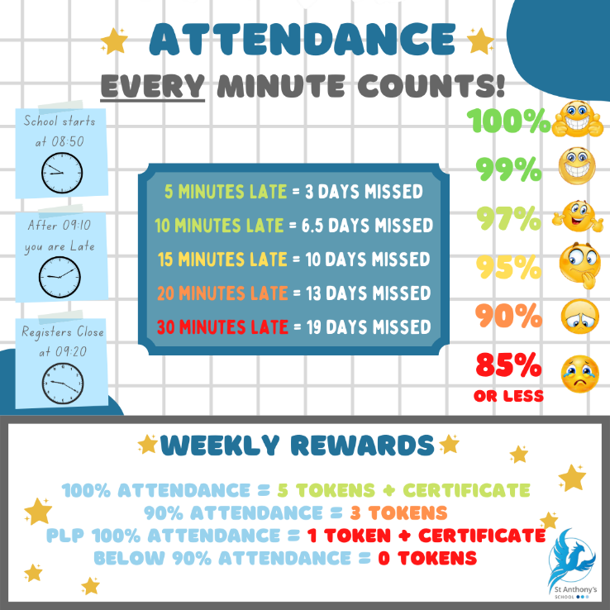**Mutual Respect & Tolerance** - to respect those from different backgrounds

**Attendance**Did you know your child’s attendance affects your child’s success? Being in school, on time, every day is vital for student’s well-being, not just their educational growth but for their development in so many other areas such as social and emotional development. We understand that our students needs are far different from the students in mainstream school, so this year we are aiming for a whole school attendance of at **least 85%.** To achieve this, we are continuing our promotion and praise of individual school attendance.

**How is Attendance at St Anthony’s rewarded?**

We monitor and reward attendance on a weekly, termly and yearly basis with a variety of rewards up for grabs. Our weekly attendance is monitored from a Friday to a Thursday, this allows us to celebrate that week’s attendance achievements in our school assembly on a Friday morning.

Students who obtain 100% attendance from the Friday to Thursday will receive a certificate and 5 Reward Shop Tokens. Students who receive 90% attendance in the same period will receive 3 Reward Shop Tokens. We also recognise that our students who have a Personal Learning Plan (or a PLP) will never obtain 100% or 90% attendance due to their learning plan. Therefore, students on a PLP who attend 100% of their PLP during the weekly time-frame are rewarded with a certificate and 1 Reward Shop Token.

The Termly monitoring is based upon the old 3 term school year, Term 1 running until Christmas, Term 2 until Easter and Term 3 until Summer. For every student who achieves 100% attendance for the Term will receive a pin badge and a certificate. The colour of the pin badge is determined by how many TERMS the student has achieved 100%. Bronze will be awarded for all students who have achieved 1 Term of 100% attendance. Silver is awarded to all students who have achieved 2 TERMS of 100% attendance and Gold is awarded to all students who have achieved all 3 TERMS of 100% attendance. Also, ALL students with an attendance of 95% or above will be entered into a draw to win 1 of 3 vouchers worth £20, £10 and £5.

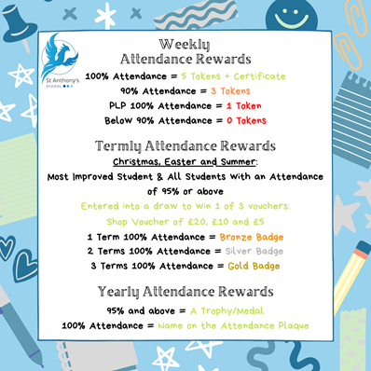The Yearly monitoring is quite simple, all students who receive 95% attendance or above will be presented with a certificate and medal. Students who receive 100% attendance for the year will receive a certificate and medal to take home and their name will be etched onto our Attendance Plaque.



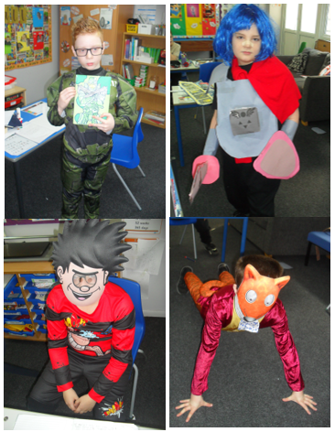





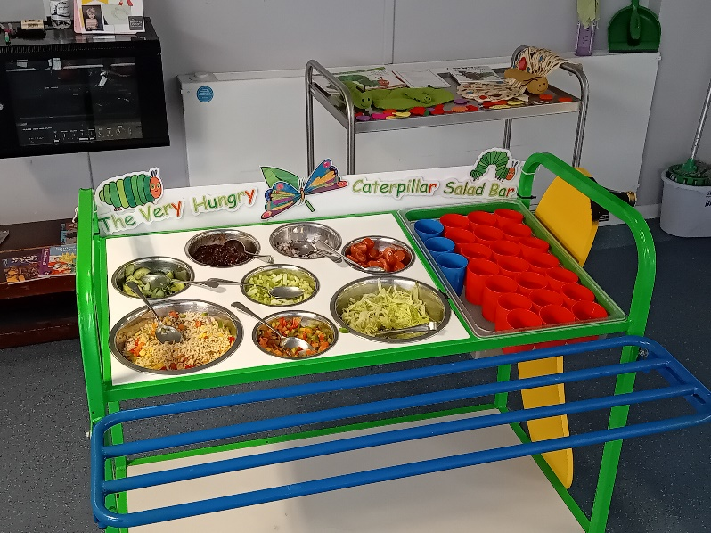

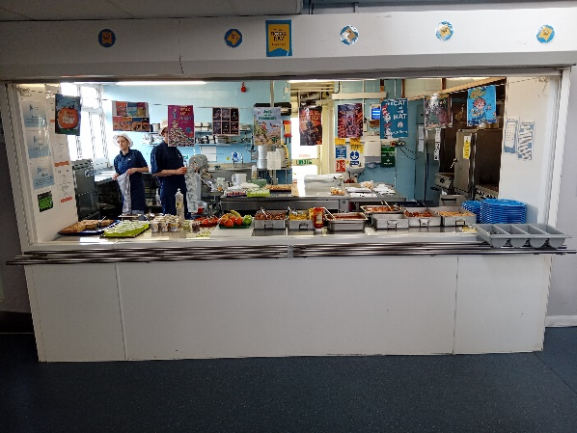

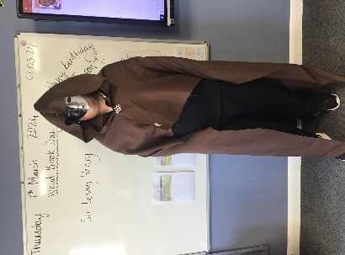



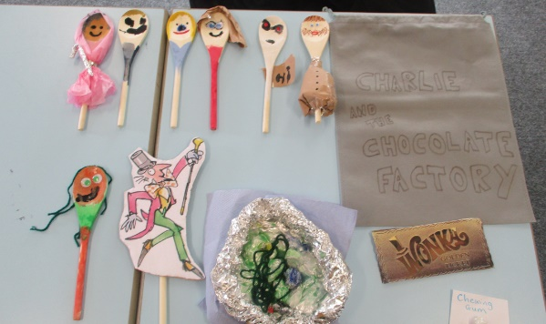

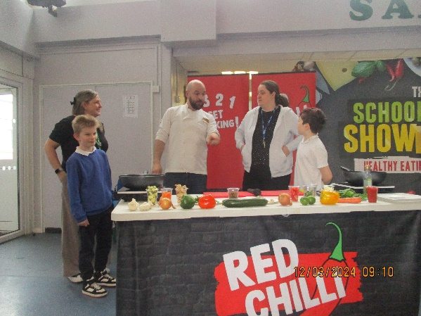 **Ready Steady Cook!**

***Y  
U  
M  
MY***



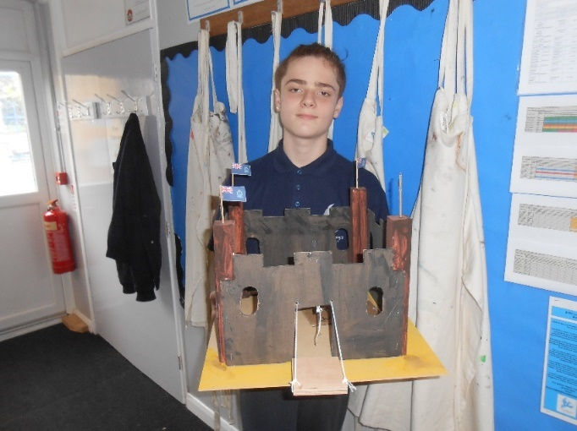



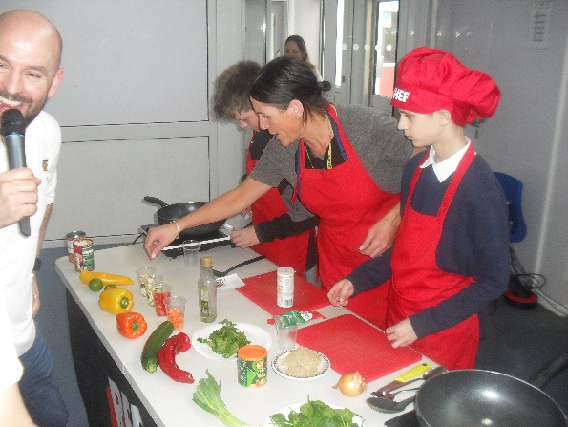



**Louisa’s Cinema Trip!**

Louisa were treated to a top trip to see Teenage Mutant Ninja Turtles in Herne Bay. The boys had an amazing time!

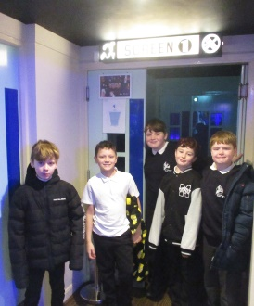

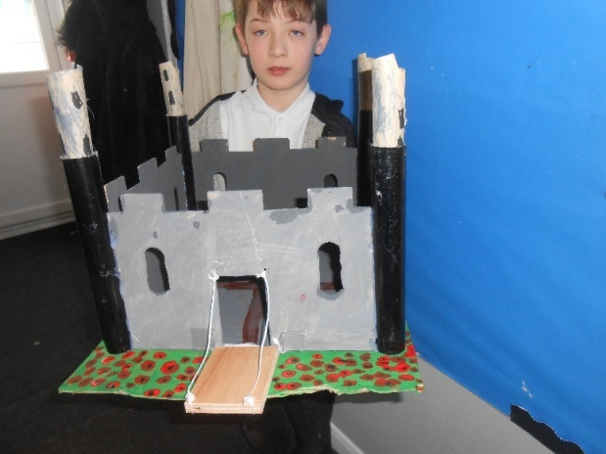 **Castles fit for royalty!**   
  
***Isaac*** made his Toy Castle which we made in DT linked to the Kings and Queens theme being covered in the school, to look like the Tower of London surrounded by a Poppy Moat. He spent a lot of individual quite time put detail to this project.

***Alfie*** totally made and decorated this castle independently. A lot of attention to detail and also added the Sea Cadet Ensigns on top of each tower.   
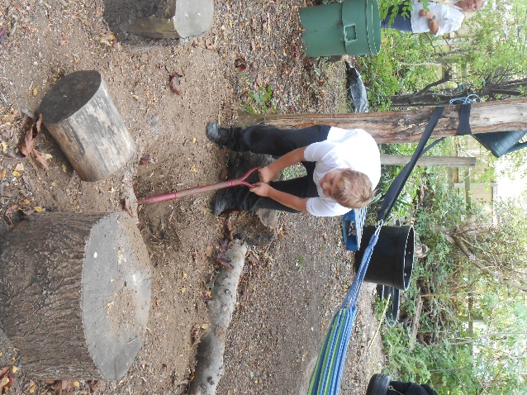**Forest School Project**  
Despite delays due to weather and the need to get students through assessments towards their BTEC Level 1 Construction qualification the Forest School Project to build a shelter is making progress. All the posts are dug down 2ft and secured with concrete. The plate rafters are now all fitted and secure so the Roof rafters will be pitched in the coming week and then the roof 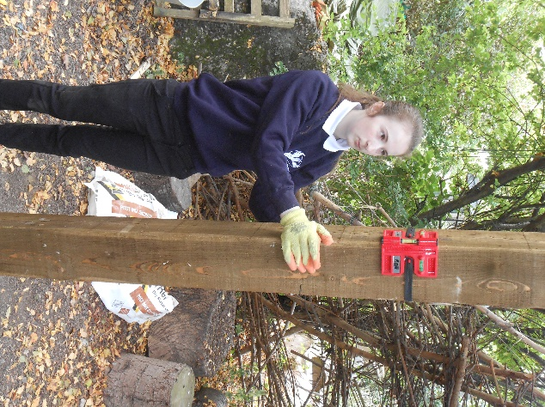boarded and covered with felt.

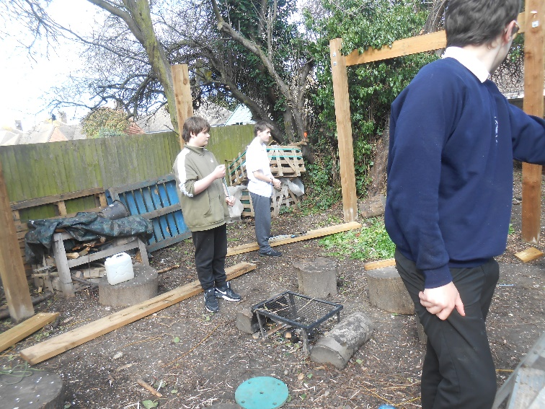**Whats on…**

**SPORT FOR FUN –** Saturdays (term time) 9.00 - 10.00 at St Anthony's School. A Saturday morning sports club for children with SEND.

**BE ACTIVE -SHORT BREAK** - Saturdays (term time) 10.30 - 12.00 at Foreland Fields School

**BE ACTIVE -SHORT BREAK** - Wednesdays (term time) 4.30 - 6.00 at Foreland Fields School

complete the following referral form to declare interest: <https://forms.office.com/r/EZwuMEZmEd>

**CLIP N CLIMB** - Thursdays Session 1: 4.30-5.30pm Session 2: 5.30-6.30pm.

To book please clink on this link: <https://forms.gle/EHYHiAtxWfE3XYDz6>

**MARGATE YOUTH FC KICKS 4 KIDS** - Tuesdays 5.00-5.45 at Margate FC   
Inclusive football sessions delivered by Inclusive Sport. To register please visit: <https://www.margateyouthfc.co.uk/events/kick-inclusive-football-sessions>   
 **Cost of Living Support**

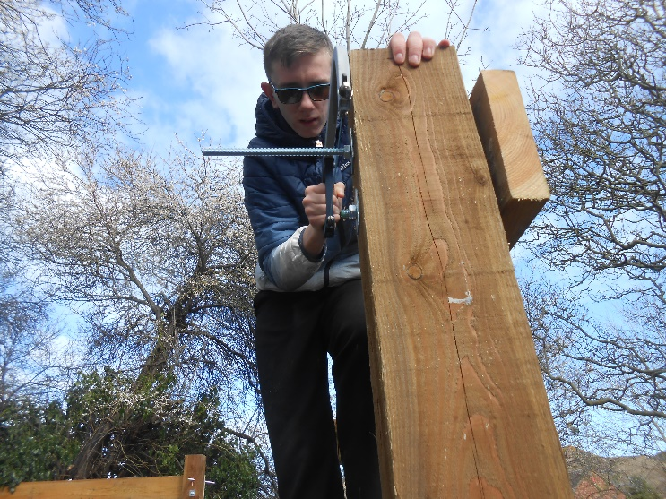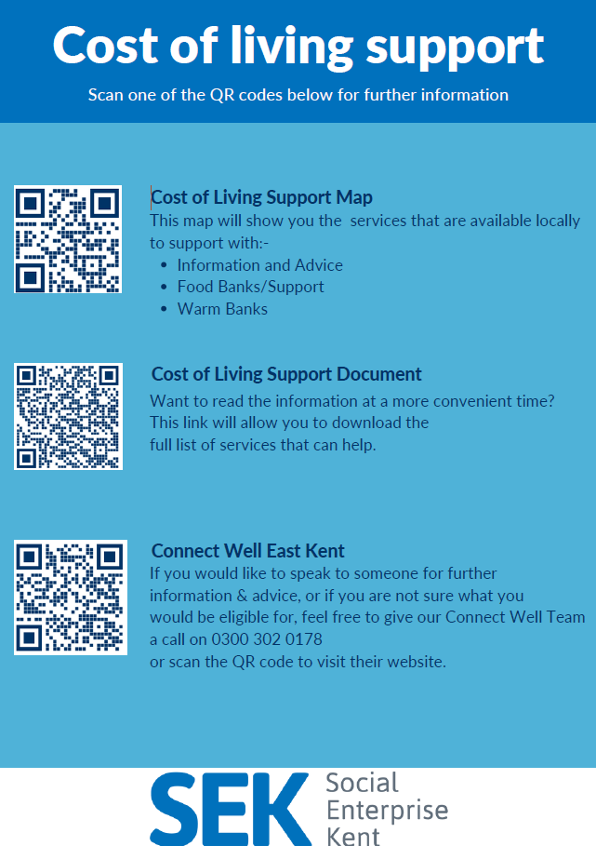

With the pressures of costs around us there is a number of services that can support. If you are having troubles please contact them direct or come and talk with us.

A link below is Thanet councils community hub which can sign post to a range of support functions.

[**https://www.thanet.gov.uk/info-pages/covidcommunityadvice/**](https://www.thanet.gov.uk/info-pages/covidcommunityadvice/)

**DWP - Outreach sessions for families**

Outreach sessions are being held in local venues. Support on hand includes, benefit advice, childcare choices and cost, finding work, cost of living, housing and any queries that our work coach can support the family with.

**Ramsgate** – The Priory Children’s Centre, Cannon Rd, Ramsgate CT11 9SQ

Outreach available every Wednesday between 9am to 12noon. To book a slot to see our adviser at the Priory Children Centre in Ramsgate please contact [jayne.conroy@dwp.gov.uk](mailto:jayne.conroy@dwp.gov.uk)

**Margate**– Six Bells Children Centre, 201 High St, Margate CT9 1WH

Outreach available every Monday between 1pm to 4pm. To book a slot to see our adviser at the Six Bells in Margate please contact

[philip.raeburn@dwp.gov.uk](mailto:philip.raeburn@dwp.gov.uk) or [anita.taylor@dwp.gov.uk](mailto:anita.taylor@dwp.gov.uk)

Visit [Kent Resilience Hub](https://kentresiliencehub.org.uk/) where you can increase your understanding, find approaches and tools or navigate your way to support and services relating to resilience and emotional wellbeing.

****[Kooth online](https://www.kooth.com/) support and counselling for 10-25 year olds across Kent and Medway. Offering 1-2-1 counselling, helpful articles, community discussion boards and daily journals.  
[MindEd](https://www.minded.org.uk/) is a free educational resource on children and young people's mental health for all adults.

Find out how to tackle hate online and online trolls with internet matters advice guide for what [online hate](https://www.internetmatters.org/resources/tackling-online-hate-and-trolling/) is and how to support your child. Get tools and tips to support your child’s [digital wellbeing](https://www.internetmatters.org/?gclid=EAIaIQobChMIrbTX5_bt7AIVRuztCh33bQH_EAAYASAAEgLtifD_BwE) on Facebook, Instagram and WhatsApp.

Call NSPCC on 0808 800 5000 if you’re worried about the safety of a child. Or call the police on 999 if you think a child is in immediate danger.

Mind's [Action for Children](https://minds.actionforchildren.org.uk/self-esteem) around self esteem and helping your child. Parents with Confidence help your child to emotionally regulate.

Free and confidential advice from [Family Lives](https://www.familylives.org.uk/how-we-can-help/confidential-helpline/) on 0808 800 2222 if you’re finding it hard at home with your child and are struggling to cope**.**

[Young Minds](https://youngminds.org.uk/) have a parent’s helpline, information and resources.