22nd October 2021
Dear Parents/Carers

I am not sure where the term has gone but it has clearly gone. Term 1 is always a very hectic term, with lots going on to provide your child with a wide range of learning opportunities. We are slowly beginning to see classes settle into the correct school routines and most pupils are coping very well.

Thank you for all those parents/carers who are helping to ensure that your children are ready for learning in school each day by having good bedtime and morning routines in place and ensuring they are in proper school uniform. If you are having problems getting ready for school please feel free to contact your child’s class teacher as we can help you if need assistance. We are successful when we work in close partnership with home to remove the barriers to learning so please ask.

Have a lovely October break.

Reminder please continue encouraging twice weekly testing

COVID appears to be in the news again for the wrong reason.
Thank you for all your work to encourage testing. Up to one in three people who have COVID-19 can spread the virus without knowing. This is because they have no symptoms. So please continue to test twice a week.

Prior to pupils return in term 2 please can you ensure that your secondary aged child does a test. Pupils will be taking home another set of LFTs to ensure they are able to test. By testing your child twice a week over half term, you will help us to reduce transmission of Coronavirus in St Anthony’s and help us to keep the school open, to minimise disruption to their education and to you and your household.

Reporting test results is just as important as taking the test, as this allows us to understand the virus and take additional action when needed. Please remember to report your results on NHS Test and Trace.

COVID-19 Vaccinations

We are pleased to announce that COVID-19 vaccinations will be taking place on Wednesday 17th and Thursday 18th November. Letters will be sent out after the half term break for you to register, if you would like your child to be vaccinated and have not already done so.

Holiday Food Vouchers

KCC is working to make sure that families who are eligible for benefits-related free school meals will receive vouchers to feed their children during school holidays. You should have received a £15 voucher per eligible child, which can be spent in supermarkets and local shops. If you have not received a voucher, please contact the office.

St Anthony’s School Council

Our school councillors this year are:
Chris L, Damien D, Logan B, Stanley B, Kaitlynn A, Max F, Shay-Lee W, Joshua W, Toby F, Ricki Q, CJ W. They were elected by their classes and met for the first time this term. It was a productive meeting. We discussed school dinners and they are asking about the possibility of more variety.
Break times were also on the agenda as there was a request for more equipment in secondary; the suggestion of a reading corner; and the possibility of different privileges for Yr10 and 11 pupils.
Litter, as always is a hot topic. As was the cleanliness of toilets, showing their environmental awareness and the need to save energy across the school.
These discussion points are carried forward to SLT and decisions made as to how they can be responded to.

Sport is back!!

Well in reality sport never really left, in fact it was one of the things that kept many of us sane through-out the madness. St A's has recently had football matches against Laleham and Learning Ops visiting KS4 with St A's prevailing in both games, winning 3-1 against Laleham and 8-1 against Learning Ops, both games played in great spirits and sportsmanship.

St A's KS3 football team were also in action against Learning Ops coming away with a 3-1 win. In addition to the games held at St A's, the school is now involved in Thanet Inclusive Games, which will run sporting events every term for pupils to take part in. This term has seen St A's attend 3 football tournaments at Ramsgate FC where being 'inclusive' is the key, allowing everyone to take part and show teamwork and honesty, with these two key values being shown in abundance by all schools involved.

Next term we have Dodgeball on the Thanet Inclusive Games Calendar in which St A's are hosting matches, additional football fixtures against The Lighthouse and Laleham schools, Benchball against Laleham and Boccia against Laleham.
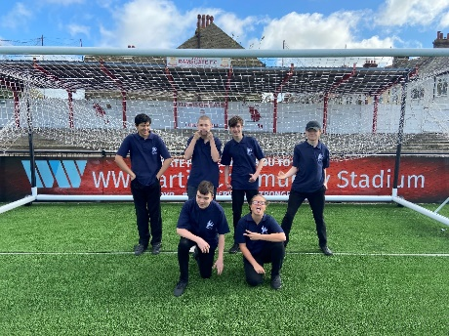
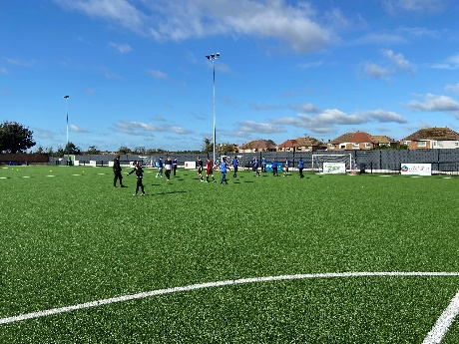
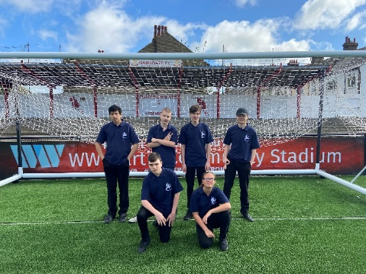

The Smile Challenge!!

It is wonderful to see our Students smiles again! To keep those smiles healthy, we will be supporting them with the Smile Challenge next term. So, we will be encouraging all our students to brush their teeth and keep their oral health in check. We will hold small presentations in the classrooms and provide free toothbrushes, to keep those smiles beautiful. If you would like additional information, please speak with Michela.

Show Racism the Red Card

St Anthony’s showed racism the red card by having a non-uniform day as pupils wore red on 22nd October. Pupil’s had an assembly and session in classes to learn how racism can have a harmful impact on victims and what they can do to help eradicate it.
For more info -
https://www.theredcard.org/

Kent Police Open Day

In September, a few primary children went to the Kent Police Open Day in Maidstone.
This event promoted the vital and diverse role of policing across the county, from training our officers through to receiving and responding to emergency calls. It also highlighted how we work with partners to deal with crime and disorder, protect the public from harm, and keep Kent safe.
During our visit we were able to meet officers and watch their teams in action. From exploring all the police vehicles through to equipment that they use, the children had a lot of fun. It was a very informative day. There were stands, activities and displays that we watched and visited.

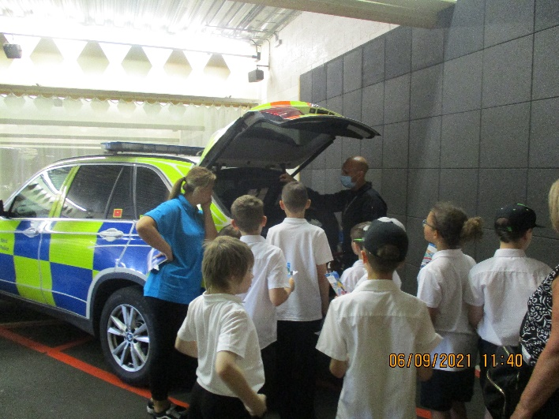

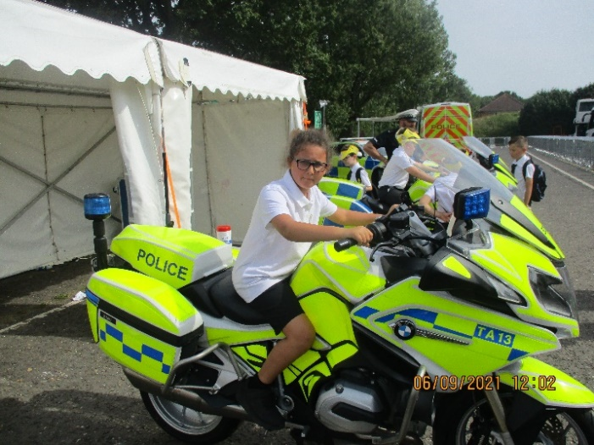
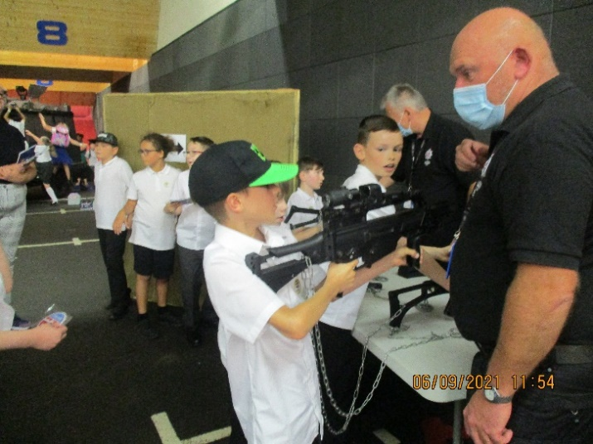

The building blocks of good mental wellbeing

Everyone can do three things for good mental wellbeing:
- Exercise
- Eat well
- Get good sleep
The benefits that come with all three are powerful and combined, can also help ease symptoms of mental illness. In some cases, they can even prevent disorders from developing.
Everyone can create healthy habits and a lifestyle that supports your mental wellbeing through a few simple steps taken at your own pace. Be kind to yourself and remember that you might not find it easy to accomplish everything each week – but that’s ok!

KCC SEND Newsletter

Please find the link below to the KCC SEND Newsletter – Back to School Edition.
https://mailchi.mp/kent.gov.uk/hyfbodx7kl

Autism Courses

All Dimension has managed to secure more funding for Kent residents, so they are able to offer the following courses fully funded:
- Level 2 Certificate in Understanding Autism
The course listed above is delivered once a week over 12 weeks
Start Date: 13/01/2022
- Introduction to Understanding Autism
This course is delivered once a week over 6 weeks – Knowledge only, so no coursework to complete but an in-house certificate will be issued. – Start Date: 02/11/2021
If anyone is interested, please contact Loretta.bishop@alldimension.co.uk for application forms.

Mr R Page Headteacher

Dates
Friday 22nd October Last Day Term 1
Monday 1st November First Day Term 2
Monday 29th November Training Day no pupils in
Friday 3rd December Winter Fayre 5 – 7pm

