**1st July 2024**

Welcome to the Summer Term at St Anthony’s!

We are excited to kick off an exciting term filled with learning, creativity, and fun.

Our students continue to engage in the full range of learning activities, from science experiments and creative arts, to outdoor sports and trips out.

We had wonderful weather for the summer Fayre and it wonderful to see so many families and children having a good time.  Thank you for your support we were able to raise almost **£1200** to support our pupils learning.   
 ***Mr Robert Page, Headteacher***  
**Dates for the diary**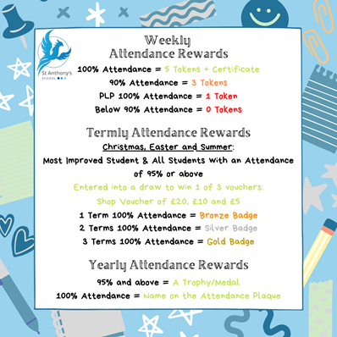

* **Friday 28th June –** Sports Day
* **Thursday 4th July** – Transition Day
* **Tuesday 23rd July** – Last Day of Term – 1:30pm finish

**British Values**

* **Democracy** - have the right to have your voice heard
* **Individual Liberty** - Promote freedom of choice
* **Rule of Law** - The importance of law and rules
* **Mutual Respect & Tolerance** - to respect those from different backgrounds

**Attendance**Did you know your child’s attendance affects your child’s success? Being in school, on time, every day is vital for student’s well-being, not just their educational growth but for their development in so many other areas such as social and emotional development. We understand that our students needs are far different from the students in mainstream school, so this year we are aiming for a whole school attendance of at **least 85%.** To achieve this, we are continuing our promotion and praise of individual school attendance.

**How is Attendance at St Anthony’s rewarded?**

We monitor and reward attendance on a weekly, termly and yearly basis with a variety of rewards up for grabs. Our weekly attendance is monitored from a Friday to a Thursday, this allows us to celebrate that week’s attendance achievements in our school assembly on a Friday morning.

Students who obtain 100% attendance from the Friday to Thursday will receive a certificate and 5 Reward Shop Tokens. Students who receive 90% attendance in the same period will receive 3 Reward Shop Tokens. We also recognise that our students who have a Personal Learning Plan (or a PLP) will never obtain 100% or 90% attendance due to their learning plan. Therefore, students on a PLP who attend 100% of their PLP during the weekly time-frame are rewarded with a certificate and 1 Reward Shop Token.

The Termly monitoring is based upon the old 3 term school year, Term 1 running until Christmas, Term 2 until Easter and Term 3 until Summer. For every student who achieves 100% attendance for the Term will receive a pin badge and a certificate. The colour of the pin badge is determined by how many TERMS the student has achieved 100%. Bronze will be awarded for all students who have achieved 1 Term of 100% attendance. Silver is awarded to all students who have achieved 2 TERMS of 100% attendance and Gold is awarded to all students who have achieved all 3 TERMS of 100% attendance. Also, ALL students with an attendance of 95% or above will be entered into a draw to win 1 of 3 vouchers worth £20, £10 and £5.

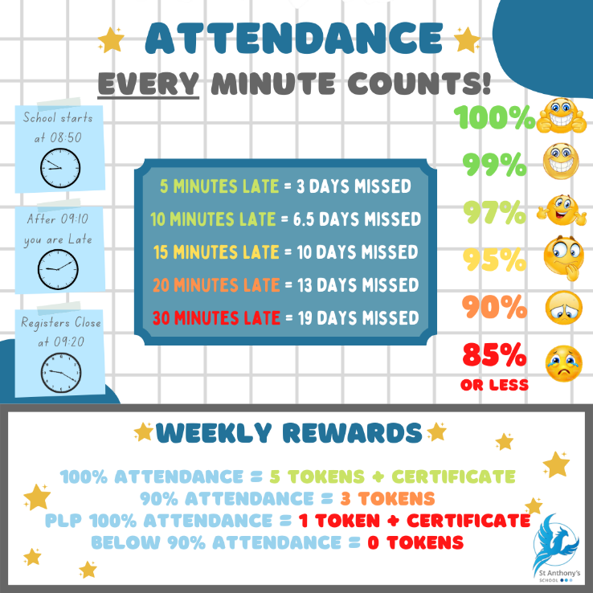The Yearly monitoring is quite simple, all students who receive 95% attendance or above will be presented with a certificate and medal. Students who receive 100% attendance for the year will receive a certificate and medal to take home and their name will be etched onto our Attendance Plaque.  **Uniform Challenge**Each week we are challenging classes to work together to win the best uniform award.

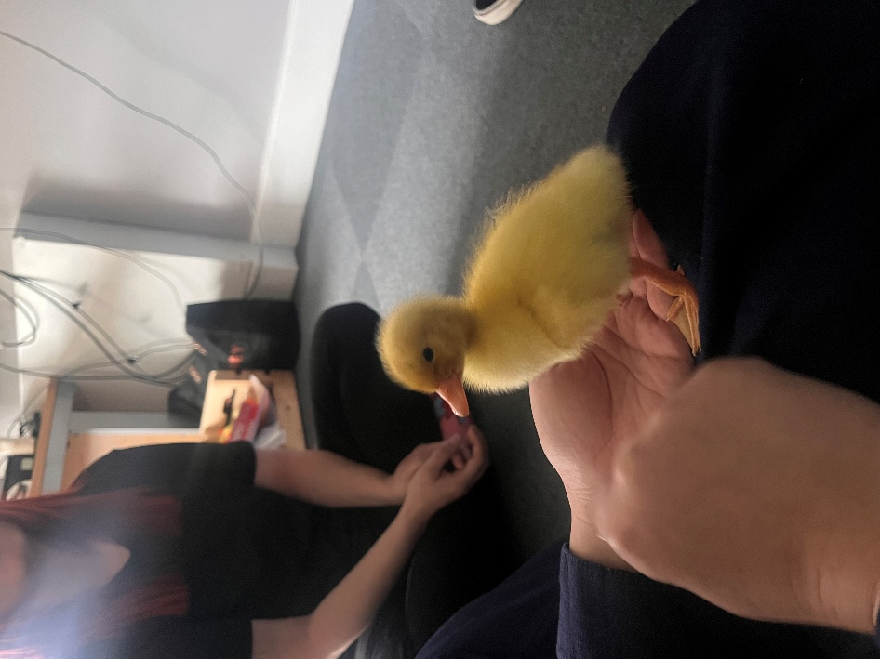Whilst we understand uniform can be expense and come with sensory challenges for some young people we would like parents to work with us in ensuring uniform or similar colours are worn. This means:

* White logo’d or plain polo shirt
* Black plain trousers
* Navy blue logo’d or plain jumper, fleece or cardigan in the colder months.

If you are having issues with uniform please contact the school to see if there is any way we can support you.

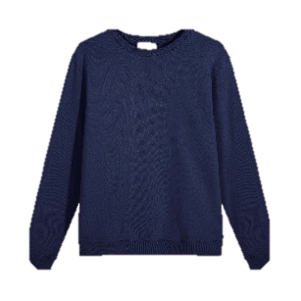 **Enterprise Fayre**

Last week saw the second year of the Maths Enterprise Week take place across the whole school with the grand finale being the fayre, show cased on Friday morning.

Throughout the week children researched, shopped, cooked and created their goods to sell and compete at the Maths Enterprise Week fair. Each class were proud to promote and present their products to sell.

**Ducklings**We were very lucky to be able to watch the starting life cycle of ducks. The eggs were incubated in Stone class with all the pupils being able to visit to see the transition from Egg to Duckling.

What a wonderful opportunity! A big thank you to Kate Wathey for organising.

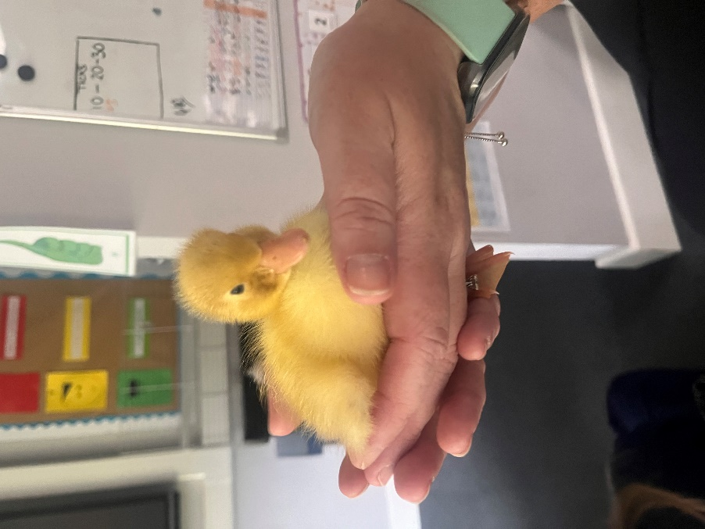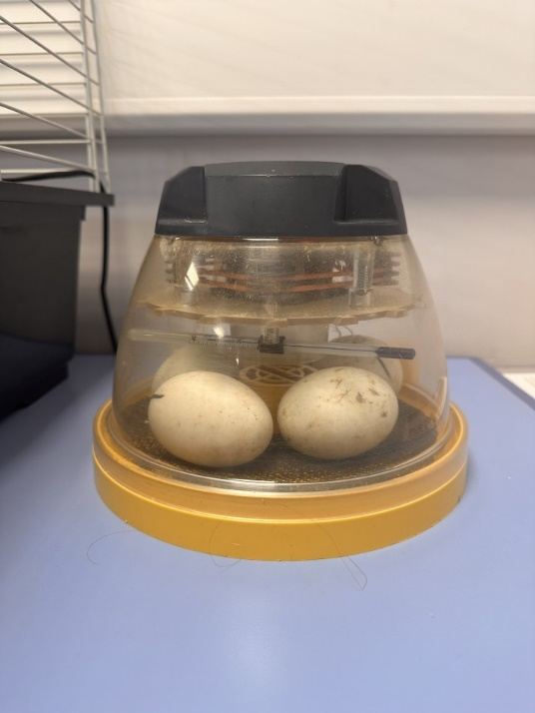

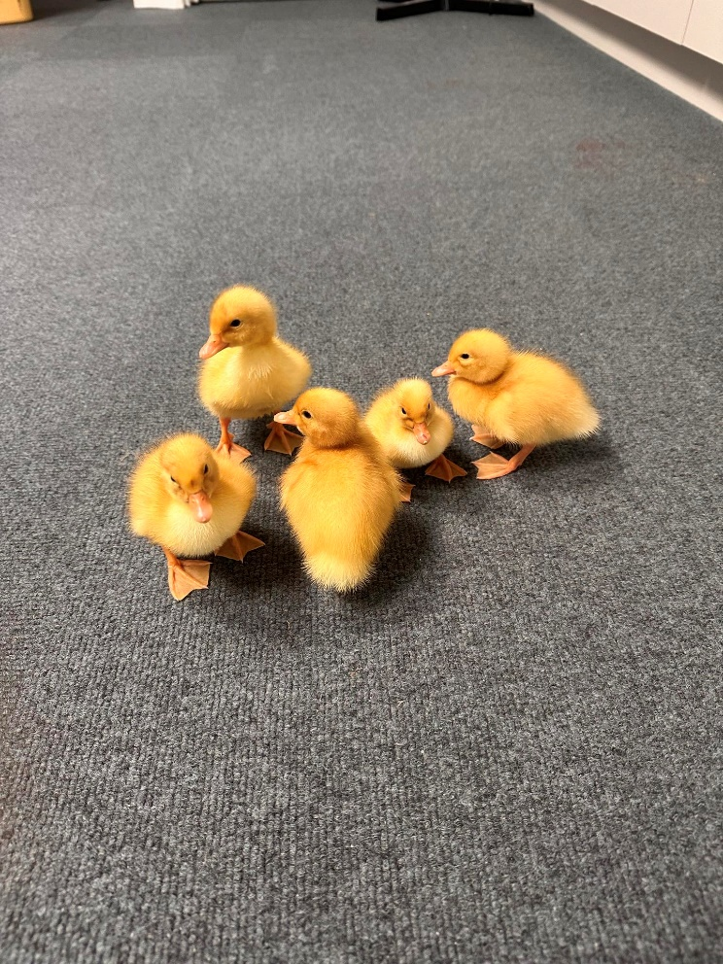  
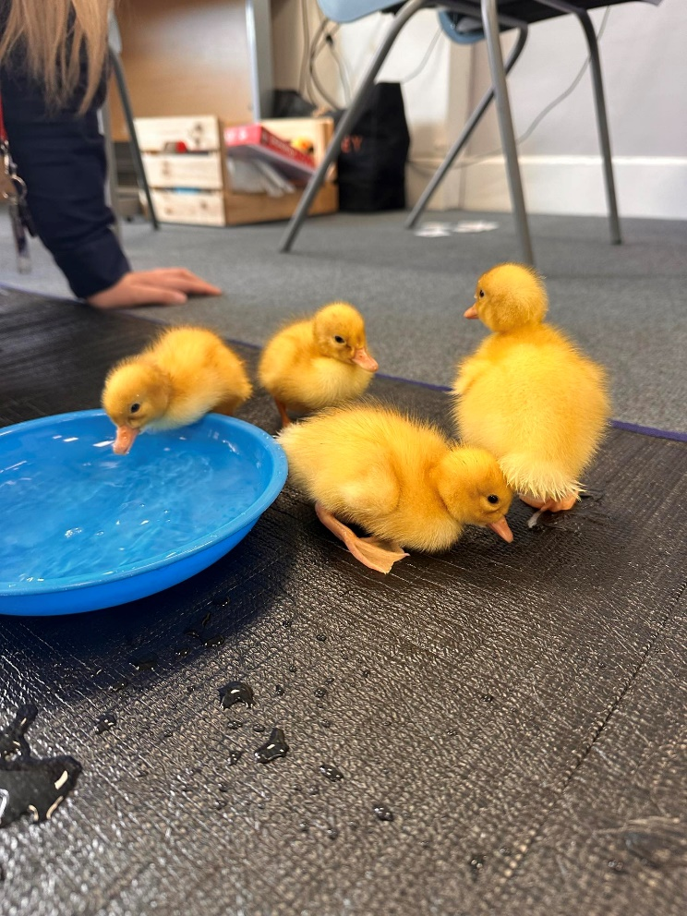  
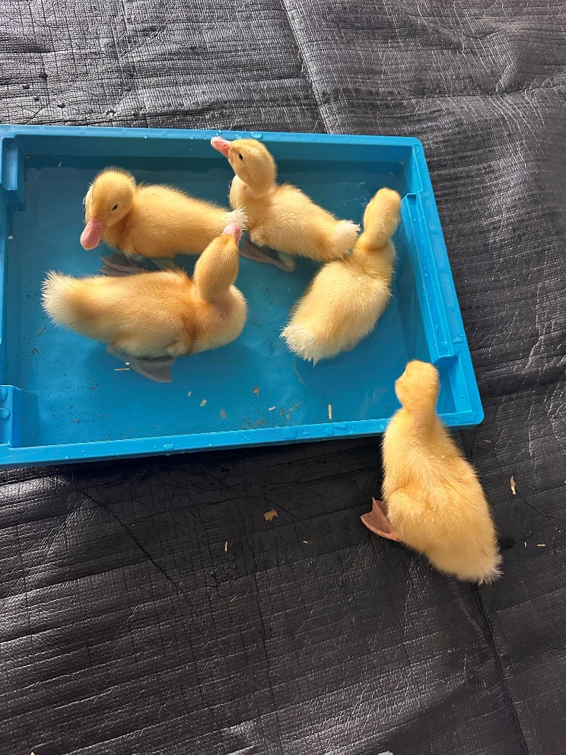

**Art Trip**This week has been a big week for the art department as we celebrate the Year 11's GCSE work at our annual exhibition.   
  
All their achievements over the two years whilst studying their Art, Craft and Design course are exhibited and we could not be prouder of them. We also took 15 students from the secondary classes to London to Frameless near Marble Arch station. As well as navigating the London Underground and trains across London, students were able to engage with an immersive art experience. World famous artworks were projected onto mirrors, screens, the ceiling and the floors to involve the audience in an ever moving and interactive art show.   
  
This was shown in 3 large rooms of different themes and was nothing like the students have seen begore. It has allowed the students (and the adults) to be totally immersed within the artwork, becoming a part of the work itself. The behaviour on the trip was outstanding and we would not hesitate to take all the students to London again.  
 ***Holly Muxworthy, Art Teacher***   
  
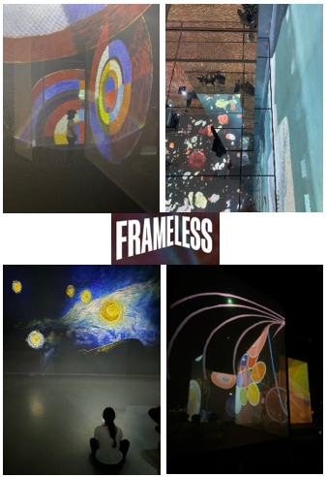

**Forest School Facts**

**Veg Patch**

Our vegetable garden is Thriving with activity and we are beginning to see some fresh produce as a result of the nurture and care the children are giving the space.   
  
This week our white radish were ready and you can see from the pictures how successful they are. Thank you to Harry for taking the time to help harvest these delicious vegetables.

These white radish have been available on the lunch time salad cart and I have seen many children excited to taste them along side their meal.

We were also able to incorporate them into the cooking lessons this week where groups have been creating an oriental chicken noodle salad.

We will soon be ready to harvest our potatoes and onions.   
 ***Ame Friend, Forest School Lead***

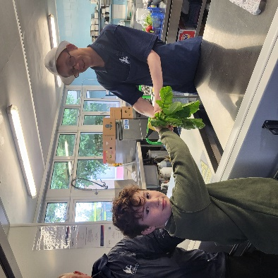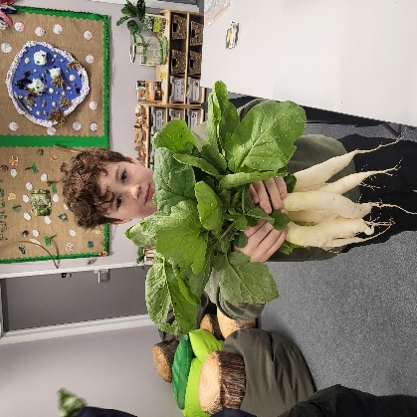



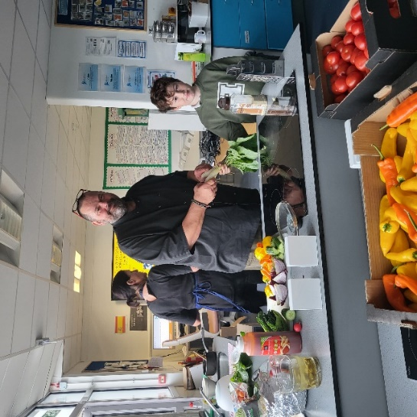

**Beach School**

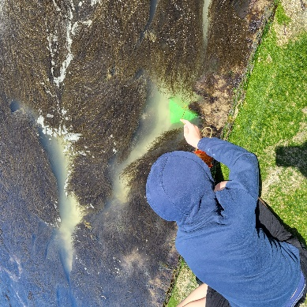Botany class enjoyed a session of beach school this week. We found and identified many different species of marine life and discussed the importance of returning everything we found, back into the sea. Well done to ***Bobby, David*** and ***Stanley*** for conquering your fear of crabs,

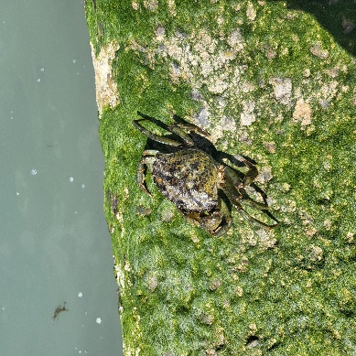

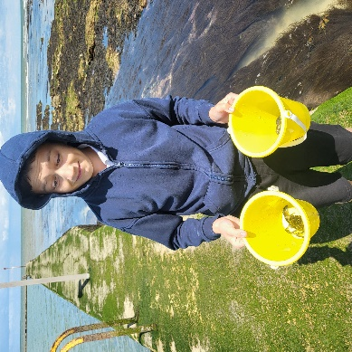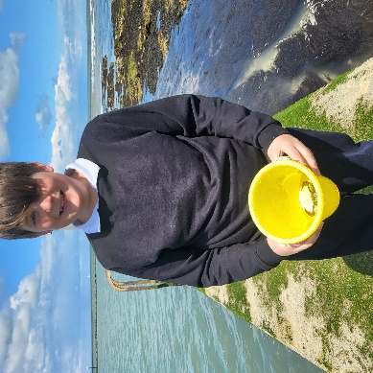you did amazingly well!  
 ***Ame Friend, Forest School Lead***

**Stans Spitfire**Stan has made this totally from scratch himself and decorated it from pictures provided in DT.

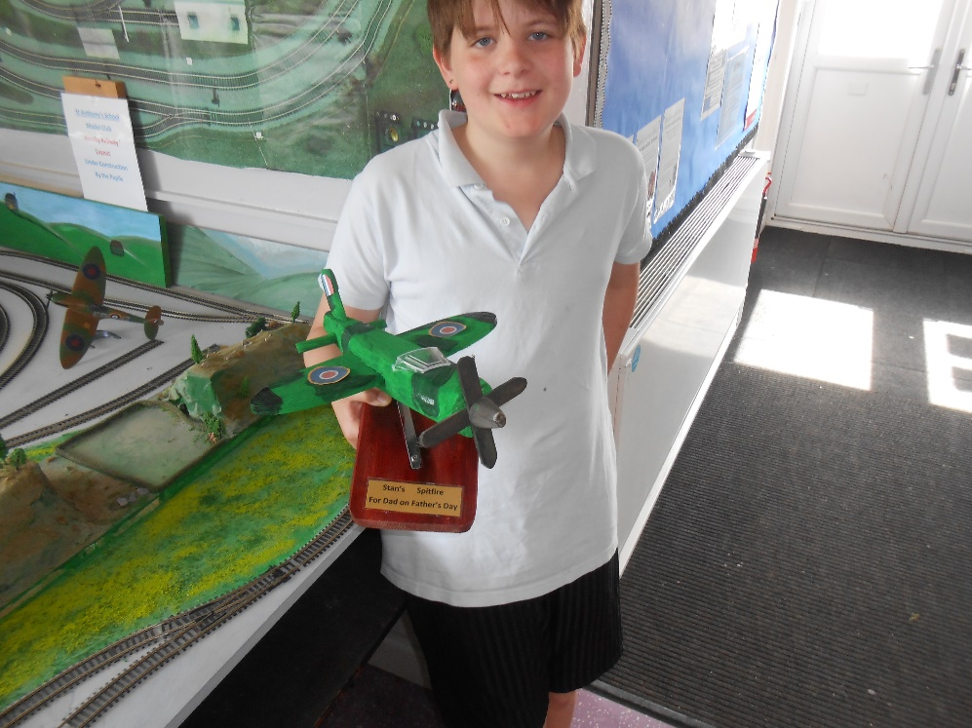All I had to do was demonstrate each process to him, Stan then showed great patience during its construction. Well done Stan!   
 ***Kevin Martin, DT Teacher***

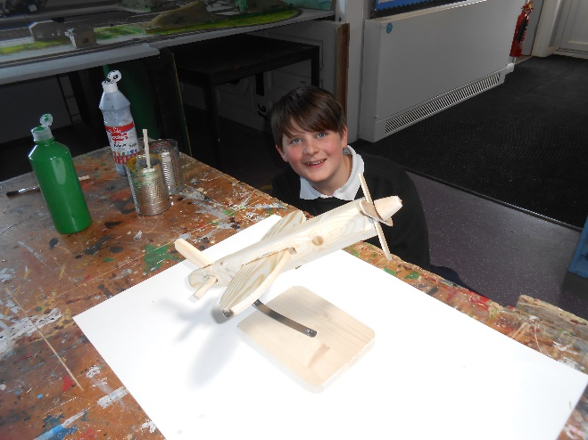

**The Little Artist’s Journey**

We were visited by former pupil **Peter Adepoju** who left in 2017 having been at the school for 13 years. Peter was able to catch up with lots of staff who remembered him. I remember having him in my class when he was Year 5 and what an amazing artist he was back then. With his amazing skills in drawing he has now gone on to successfully write and illustrate his own book children's book about being a child with Autism, his book is for sale on Amazon. Peter went round to several classes to share how his book came about and said to children to keep trying hard and follow their interests. Peter is now completing a degree in Illustration.  
 ***Abi Cranson, Deputy Headteacher***

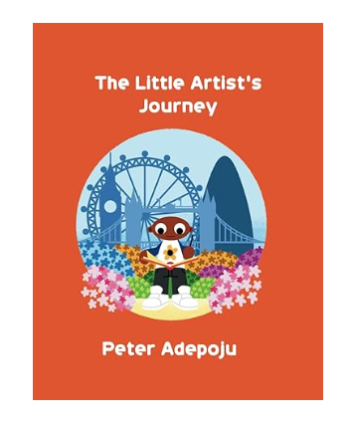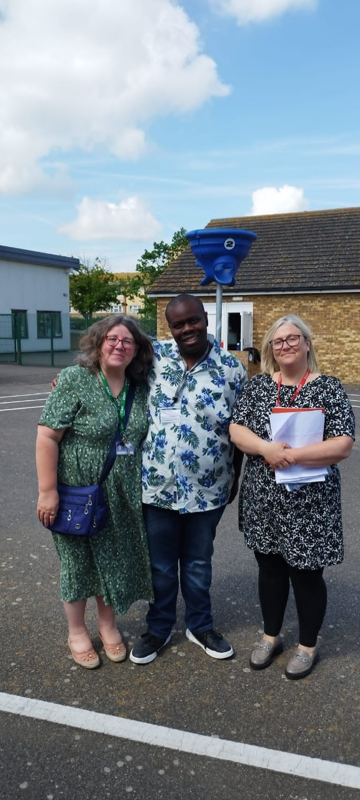

<https://www.amazon.co.uk/LITTLE-ARTISTS-JOURNEY-ILLUSTRATED-CHILDRENS/dp/B0CY9NQ97R?source=ps-sl-shoppingads-lpcontext&ref_=fplfs&psc=1&smid=A3P5ROKL5A1OLE>

**Charlies Promise**



Charlie Cosser was murdered last year at a party by a young boy who had carried a knife to the party. Charlie's family have started up a charity called Charlie's Promise and they are dedicating their time to raising awareness of knife crime.

At St Anthony's School we believe that educating our pupils through real life events and first hand speakers is so important, please take a look at the Charlie's Promise website and any questions please ask. We will covering this in the new academic year.

<https://www.charliespromise.org/>  
A number of our St Anthony’s staff are taking part in a race for life

It would mean the world to them if you could donate. This can be done via:   
<https://fundraise.cancerresearchuk.org/team/st-anthonys>   
 ***Rachel Cox, Pegwell Teacher***

**Summer Reading Challenge**





**PAWS**

PAWS provides help for young people (10-18) to overcome mental health and wellbeing-related issues that are affecting their education, home life or relationships with family and friends.

Porchlights Adolescent Wellbeing Service (PAWS) is seeking your support to find out more about the experiences of parents, carers, children and young people regarding accessing mental health and wellbeing services.

Please take a moment to look at the attached link to a short survey <https://forms.office.com/e/Z9yCtwUG9b>

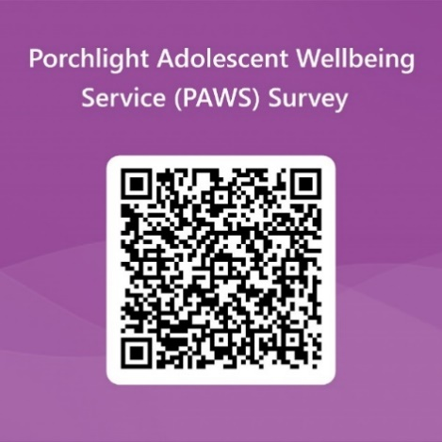

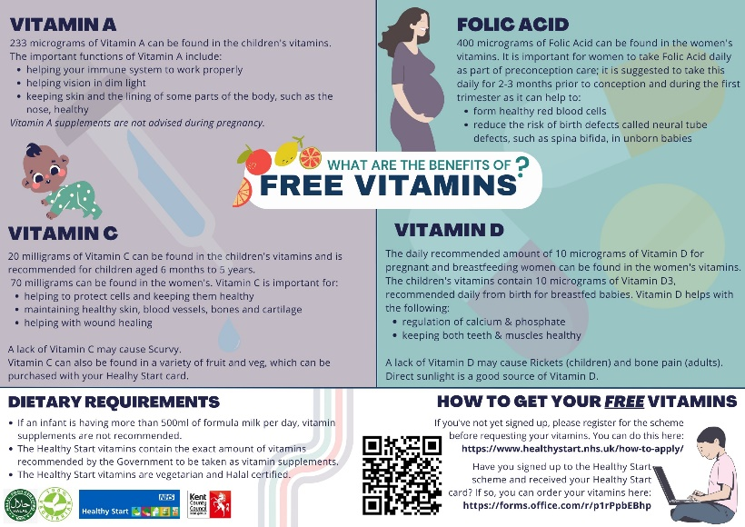

**Cost of Living Support**

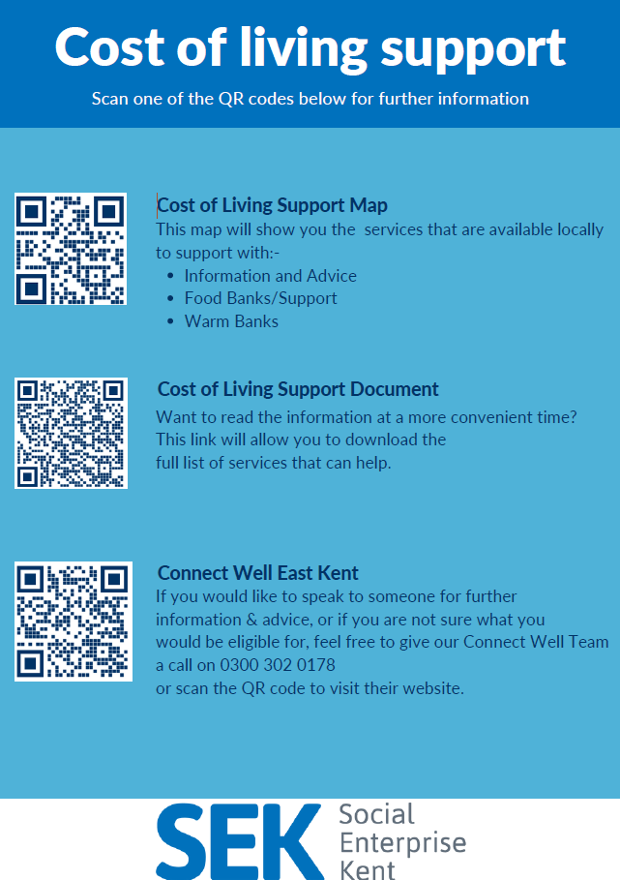With the pressures of costs around us there is a number of services that can support. If you are having troubles please contact them direct or come and talk with us.

A link below is Thanet councils community hub which can sign post to a range of support functions

[**https://www.thanet.gov.uk/info-pages/covidcommunityadvice/**](https://www.thanet.gov.uk/info-pages/covidcommunityadvice/)

**DWP - Outreach sessions for families**

Outreach sessions are being held in local venues. Support on hand includes, benefit advice, childcare choices and cost, finding work, cost of living, housing and any queries that our work coach can support the family with.

**Ramsgate** – The Priory Children’s Centre, Cannon Rd, Ramsgate CT11 9SQ

Outreach available every Wednesday between 9am to 12noon. To book a slot to see our adviser at the Priory Children Centre in Ramsgate please contact [jayne.conroy@dwp.gov.uk](mailto:jayne.conroy@dwp.gov.uk)

**Margate**– Six Bells Children Centre, 201 High St, Margate CT9 1WH

Outreach available every Monday between 1pm to 4pm. To book a slot to see our adviser at the Six Bells in Margate please contact

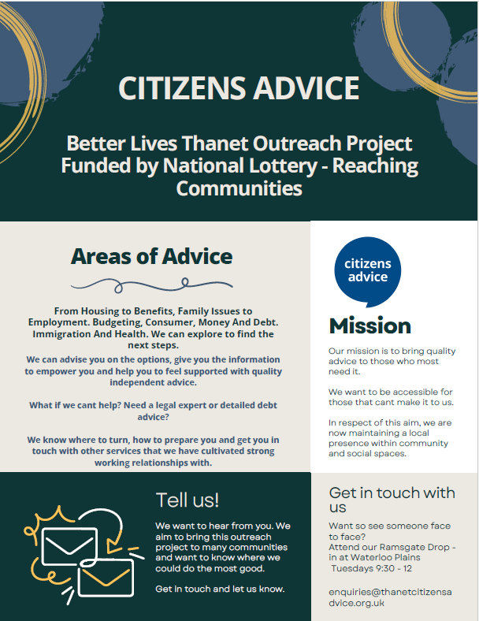[philip.raeburn@dwp.gov.uk](mailto:philip.raeburn@dwp.gov.uk) or [anita.taylor@dwp.gov.uk](mailto:anita.taylor@dwp.gov.uk)

Visit [Kent Resilience Hub](https://kentresiliencehub.org.uk/) where you can increase your understanding, find approaches and tools or navigate your way to support and services relating to resilience and emotional wellbeing.

****[Kooth online](https://www.kooth.com/) support and counselling for 10-25 year olds across Kent and Medway. Offering 1-2-1 counselling, helpful articles, community discussion boards and daily journals.  
[MindEd](https://www.minded.org.uk/) is a free educational resource on children and young people's mental health for all adults.

Find out how to tackle hate online and online trolls with internet matters advice guide for what [online hate](https://www.internetmatters.org/resources/tackling-online-hate-and-trolling/) is and how to support your child. Get tools and tips to support your child’s [digital wellbeing](https://www.internetmatters.org/?gclid=EAIaIQobChMIrbTX5_bt7AIVRuztCh33bQH_EAAYASAAEgLtifD_BwE) on Facebook, Instagram and WhatsApp.

Call NSPCC on 0808 800 5000 if you’re worried about the safety of a child. Or call the police on 999 if you think a child is in immediate danger.

Mind's [Action for Children](https://minds.actionforchildren.org.uk/self-esteem) around self esteem and helping your child. Parents with Confidence help your child to emotionally regulate.

Free and confidential advice from [Family Lives](https://www.familylives.org.uk/how-we-can-help/confidential-helpline/) on 0808 800 2222 if you’re finding it hard at home with your child and are struggling to cope**.**

[Young Minds](https://youngminds.org.uk/) have a parent’s helpline, information and resources.