**25th November 2022**

As we come to the end of November the school has been a hive of activity, as you will read in the newsletter. Reminder that staff have a **Training Day on Monday 28th November** where we will have training on positive handling with TEAM TEACH and learning more about ‘online safety’. The number of incidents of pupil’s online behaviours that the school deals with are increasing year on year, so we hope this training will be beneficial.

The School Fayre is next **Friday 2nd December** from 4:30pm - 6:30pm so please plan to come. We have not had a Winter Fayre for some time but it has always been an enjoyable school community event and l hope to see as many as you as possible. I understand that **Father Christmas** is planning to make an appearance.

We are still collecting donations and pupils have a non-uniform day on **Friday 2nd December** for donations of bric-a-brac, books and food.

Kent County Council are inviting parents and carers to complete the following short survey about the activities available in Kent for children and young people with disabilities. Results from this survey will help inform and shape the design and development of short breaks In Kent so please complete the survey. The survey should take no longer than 15 minutes and you do not need to have accessed short breaks before to take part.

Please find the link to the survey below:

[https://KCC.welcomesyourfeedback.net/shortbreaks](https://eur01.safelinks.protection.outlook.com/?url=https%3A%2F%2Fkcc.welcomesyourfeedback.net%2Fshortbreaks&data=05%7C01%7CWendy%40kentautistic.com%7C8711c083e8c642ec187008dac7248814%7C4ad4b580cdef4a3cb7e3ff9e73b3ff41%7C0%7C0%7C638041257000079543%7CUnknown%7CTWFpbGZsb3d8eyJWIjoiMC4wLjAwMDAiLCJQIjoiV2luMzIiLCJBTiI6Ik1haWwiLCJXVCI6Mn0%3D%7C3000%7C%7C%7C&sdata=ZlwEoIFRzY93cJblU0h3wD5ZE7JMwfK6H1uNV5EROUk%3D&reserved=0)

Another survey request from the KCCs Director of Education to help KCC make decisions when it comes to making decisions and working with parent groups to influence the change that is needed.

The survey is live and can be completed by all parents.

<https://kentcc-self.achieveservice.com/service/provide_feedback_on_your_child_s_experiences_of_education>

**Challenger Troop**

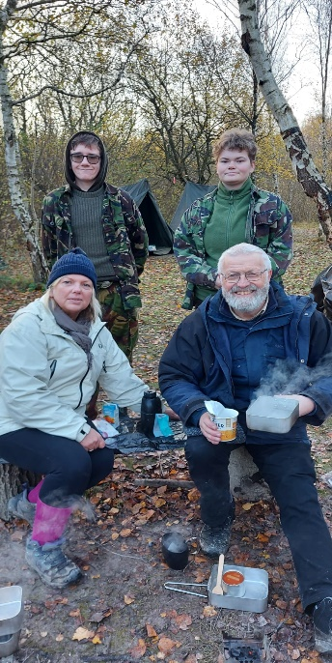 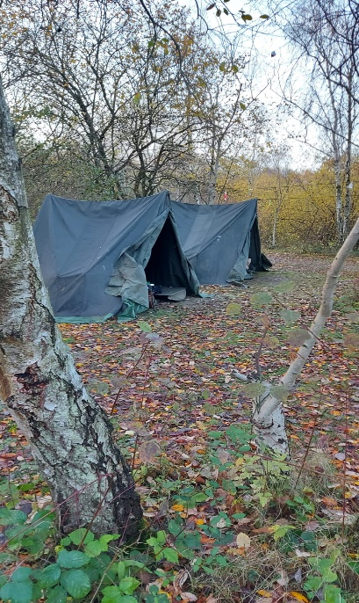

**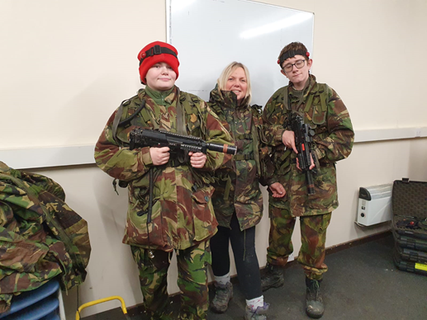*Jackie, Ryan, Kate & John cooking at camp***

***Where is Kate, Jackie & Ryan?***

On Wednesday 23rd November ***Kate*** and ***Ryan*** supported by Jackie and John were able to participate in an overnight trip as part of ****Challenger Troop course. They pitched tents and enjoyed a range of activities.

**Dahl Park Trip**

On Tuesday 22nd November Dahl class were able to escape the wet weather and get to the park for a run around. ***Bobby*** was our official photographer this week. We are not sure who had more fun…the staff or the children. Even ***John*** and ***Naz*** got in on the action.

It is safe to say everyone had a great time.

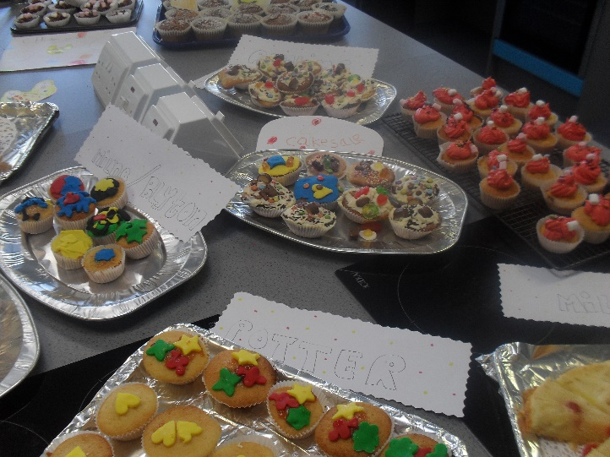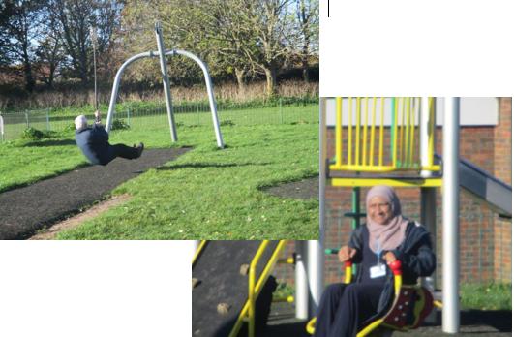  
 **St Anthony’s Sports**

**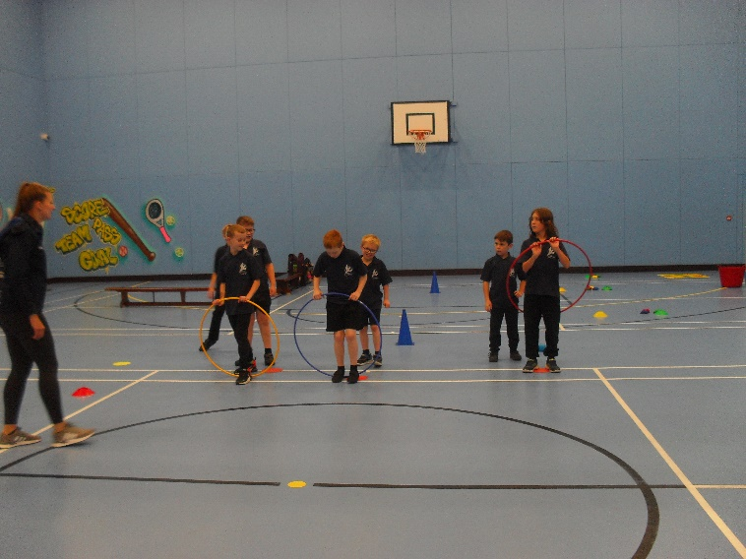**St Anthony’s hosted a sporting event with 3 other schools on Thursday 24th November.   
The main event was dodgeball. Blyton represented the school wonderfully.

**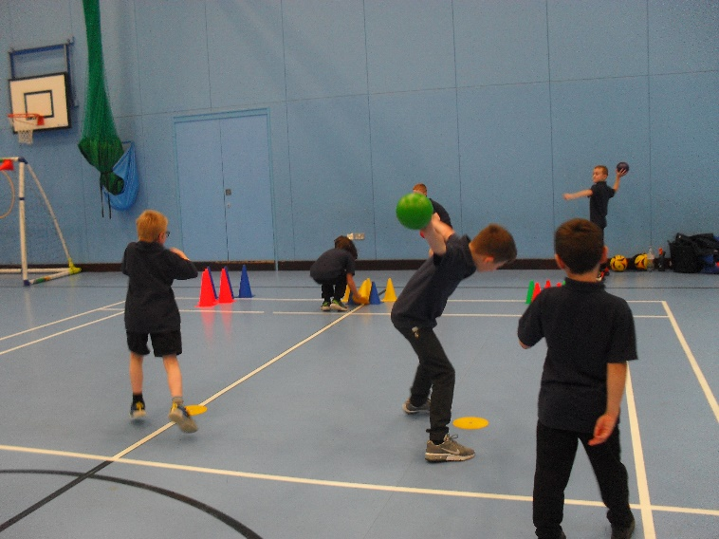**

***Junior, Ricki, James, Lewis, Craig, Isaac, Leo, Blaine & Lewis   
doing St Antony’s proud!***

**Children in Need**

On **Friday 18th November** for Children in Need the student council of St Anthony’s decided to do a cake sale to raise money. ***Matt*** and ***Alison*** supported all classes in their food tech lessons to bake. They all worked very hard and made some amazing cakes and biscuits. It was a great success and we managed to raise **£93.00** It was a team effort, and the children were all fantastic, Well done to everyone.

**England Football** flag of England | flag of a constituent unit of the United Kingdom |  Britannica



On Monday 21st November, ***Craig*** our PE teacher organised opportunities for pupils and some staff to watch England’s opening game of the World Cup. Pupils were able to cheer England on to win the game **6-2**. Pupils were very well behaved, even when 'hyped up' from the goals. After the wild celebrations of the goals they settled back down. If another game falls during school hours later in the world cup Craig will organise another event in school.

**PSHE British Values**

British Values has always been part of the curriculum at St Anthony's, but this academic year we are really promoting their positive message. In today's world of challenges and changes, for young people to know, understand and follow the British Values, will support them better to achieve both in and out of school.

Pupils will have the opportunity to achieve coloured wristbands, when they demonstrate they understand and follow a British Value. At the end of the academic year, pupils who have achieved all five wrist bands, will have the opportunity to go to The House of Commons for a guided tour.



**Safeguarding Review**

On **Monday 14th November** the school had a safeguarding review. ***Kirstie Phippin*** the schools designated safeguarding lead (DSL) organised the review.

The review highlighted lots of the good practise the school has in place to ensure that pupils are safe. She remarked on the positive atmosphere she found around the school. Pupils were polite and able to talk about how to keep themselves safe.

She also made some recommendations to improve our safeguarding in the school and over the next term ***Kirstie, Abi*** and ***Robert*** will look to implement these suggestions.



On the 14th and 18th November primary and secondary pupils enjoyed a cinema experience at the Vue, thanks to free **Into Film** tickets. The **PTFA** funded goodie bags and all pupils had an excellent time - all enjoying the reclining seats! Our primary department had a supersonic time watching **Sonic 2** and our secondary department had a spooktacular time watching **GhØstbusters!**

Pupil’s behaviour on the trip was outstanding and comments from the pupils were all positive.





**Discovery Planet**

**Saturday 26th November** is the next Discovery Planet Workshop title Electricity: How Watt and Why.



**SPORT FOR FUN –**

Saturdays (term time) 9.00 - 10.00 at St Anthony's School. A Saturday morning sports club for children with SEND.

**BE ACTIVE -SHORT BREAK** - Saturdays (term time) 10.30 - 12.00 at Foreland Fields School

**BE ACTIVE -SHORT BREAK** - Wednesdays (term time) 4.30 - 6.00 at Foreland Fields School

Please read the PDF letter attached for more information and complete the following referral form to declare interest: <https://forms.office.com/r/EZwuMEZmEd>

**CLIP N CLIMB** - Thursdays Session 1: 4.30-5.30pm Session 2: 5.30-6.30pm.

To book please clink on this link: <https://forms.gle/EHYHiAtxWfE3XYDz6>

**MARGATE YOUTH FC KICKS 4 KIDS** - Tuesdays 5.00-5.45 at Margate FC

Inclusive football sessions delivered by Inclusive Sport. To register please visit: <https://www.margateyouthfc.co.uk/events/kick-inclusive-football-sessions>

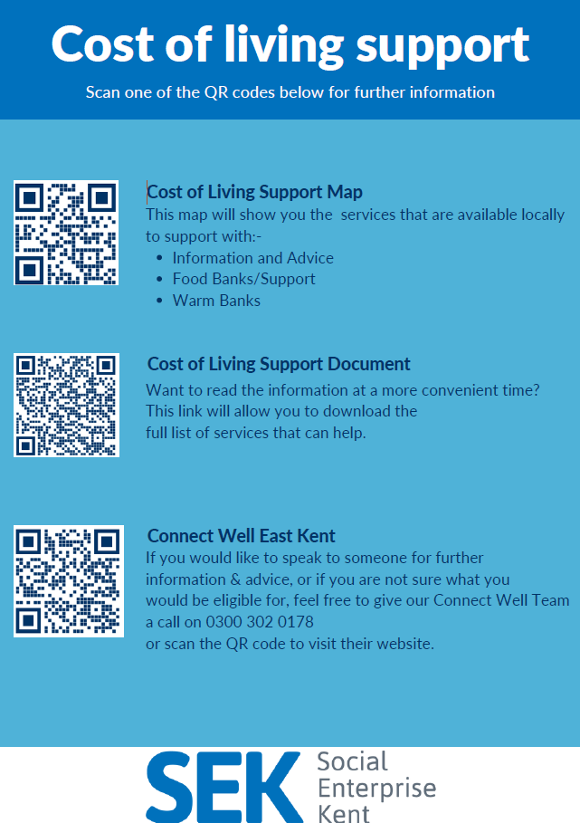

**Cost of Living Support**

With the pressures of costs all around us right now, there is a number of services that can support. If you are having troubles please contact them direct or come and talk with us.

A link below is Thanet councils community hub which can sign post to a range of support functions.

[**https://www.thanet.gov.uk/info-pages/covidcommunityadvice/**](https://www.thanet.gov.uk/info-pages/covidcommunityadvice/)

**Dane Valley Residents Association - Cost of living support cafe**

Dane Valley Residents Association is organising a cost of living and support café for the residents in Dane Valley. This will be held at **Millmead Hall** (Next to Northdown School) on the dates and times outlined below.

* Wednesday 30th November - 7pm - 10pm
* Wednesday 7th December - 5pm - 8pm
* Wednesday 14th December - 3pm - 6pm
* Wednesday 21st December - 7pm - 10pm

Venue - Millmead Hall, 115 Millmead Rd, Dane Valley, Margate CT9 3QN

The purpose of the sessions is to take services to the residents in Dane Valley. But, any

resident living in Thanet will be able to come along and access the support available. There

will be refreshments available for all partners and residents. Contact Jack Packman: [info@jackpackman.co.uk](mailto:info@jackpackman.co.uk)

**DWP - Outreach sessions for families**

Outreach sessions are being held in local venues. Support on hand includes, benefit

advice, childcare choices and cost, finding work, cost of living, housing and any queries that our work coach can support the family with.

**Ramsgate** – The Priory Children’s Centre, Cannon Rd, Ramsgate CT11 9SQ

Outreach available every Wednesday between 9am to 12noon To book a slot to see our adviser at the Priory Children Centre in Ramsgate please contact

[jayne.conroy@dwp.gov.uk](mailto:jayne.conroy@dwp.gov.uk)

**Margate**– Six Bells Children Centre, 201 High St, Margate CT9 1WH

Outreach available every Monday between 1pm to 4pm To book a slot to see our adviser at the Six Bells in Margate please contact

[philip.raeburn@dwp.gov.uk](mailto:philip.raeburn@dwp.gov.uk) or [anita.taylor@dwp.gov.uk](mailto:anita.taylor@dwp.gov.uk" \t "_blank)

**Royal British Legion - Energy Support**

The Royal British Legion, the UK's largest charity dedicated to supporting the Armed Forces community, has today launched a new grant scheme for veterans and their families who are struggling to pay their energy bills. The initiative will provide non-repayable emergency grants of up to £2,400 a year (£200 a month) and is available across the UK.

In general, the Armed Forces community includes those who have served, or are serving, in the Royal Navy, British Army or Royal Air Force, as well as their families, dependants and carers – which can include children, current and former spouses and partners, widows and widowers.

To apply it's worth [checking your eligibility on its website](https://eur01.safelinks.protection.outlook.com/?url=https%3A%2F%2Fwww.britishlegion.org.uk%2Fget-support%2Fwho-we-help&data=05%7C01%7CJenny.Hanna%40kent.gov.uk%7C0e5a983faa7040ba13ee08dab3399c0f%7C3253a20dc7354bfea8b73e6ab37f5f90%7C0%7C0%7C638019357270836664%7CUnknown%7CTWFpbGZsb3d8eyJWIjoiMC4wLjAwMDAiLCJQIjoiV2luMzIiLCJBTiI6Ik1haWwiLCJXVCI6Mn0%3D%7C3000%7C%7C%7C&sdata=3atnAtHJUwgEaZz76bOScnj82DDHbKKLWrCX4kciIcY%3D&reserved=0) or by calling its helpline on 0808 802 8080.



Visit [Kent Resilience Hub](https://kentresiliencehub.org.uk/) where you can increase your understanding, find approaches and tools or navigate your way to support and services relating to resilience and emotional wellbeing.



[Kooth online](https://www.kooth.com/) support and counselling for 10-25 year olds across Kent and Medway. Offering 1-2-1 counselling, helpful articles, community discussion boards and daily journals.

****

[MindEd](https://www.minded.org.uk/) is a free educational resource on children and young people's mental health for all adults.



Find out how to tackle hate online and online trolls with internet matters advice guide for what [online hate](https://www.internetmatters.org/resources/tackling-online-hate-and-trolling/) is and how to support your child. Get tools and tips to support your child’s [digital wellbeing](https://www.internetmatters.org/?gclid=EAIaIQobChMIrbTX5_bt7AIVRuztCh33bQH_EAAYASAAEgLtifD_BwE) on Facebook, Instagram and WhatsApp.

  
Call NSPCC on 0808 800 5000 if you’re worried about the safety of a child. Or call the police on 999 if you think a child is in immediate danger.

  
Mind's [Action for Children](https://minds.actionforchildren.org.uk/self-esteem) around self esteem and helping your child. Parents with Confidence help your child to emotionally regulate.

  
Free and confidential advice from [Family Lives](https://www.familylives.org.uk/how-we-can-help/confidential-helpline/) on 0808 800 2222 if you’re finding it hard at home with your child and are struggling to cope**.**[Young Minds](https://youngminds.org.uk/) have a parent’s helpline, information and resources.