**27th May 2022 Newsletter**

This is the last newsletter for term 5, l am not sure where the time goes but this term seems to have just started and we are finished.

Today is the last formal day for our year 11s who begin their work experience placements in term 6. It has been a challenge to arrange the work experience placements after not have work experience the past two years, well done to Mr Curry and the team who have arranged.

Last week the school had science week, with pupils doing lots of science throughout the week. The week ended with a science fayre on Friday morning which was an incredible success. A very big well done to our science lead Natalie for organise such a brilliant week for the children.

As we move into term 6 we are going to have a focus on attendance, as the school’s overall attenance figure is significantly below where we wish it to be. Looking at the data there is no one single reason, but l would like your support in ensuring that your child attends school each and every day in term 6.

Have a lovely break and enjoy the Jubilee Celebrations.

**Science Week 16th – 20th May**

Last week, we hosted a very successful St. Anthony’s ‘Science Week 2002’, whereby the pupils had a week focusing on science. After a week off learning all about ‘Healthy Me’ the pupils then had the opportunity to show off their learning.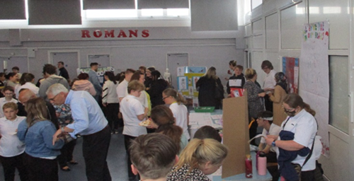

Wow! What a splendid turn out! Thank you to everyone that came along to Fridays ‘Health Clinic’ and showed their interest and support in the pupils learning. Whether you drank, dipped chocolate, lifted weights or was brave enough to try the bubble gum toothpaste the atmosphere was amazing.

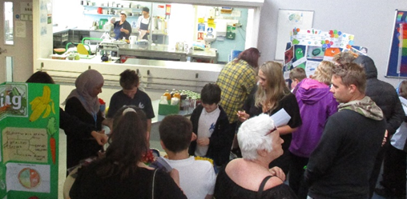

What was your favourite stall?

Each class has had a special ’class scientist award’ and everyone has received a certificate for their acknowledgement of taking part. Everyone’s efforts were incredible, (including the adults) which made the teachers jobs of selecting a class winner rather tricky.

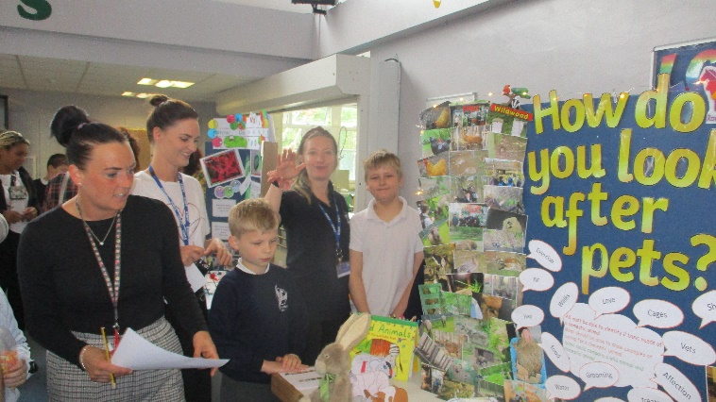

**Blyton Class, *Danielle, Cloud, Kate & CJ* answering how best look after your pets**

**The hall was buzzing with eager minds   
and budding scientists**

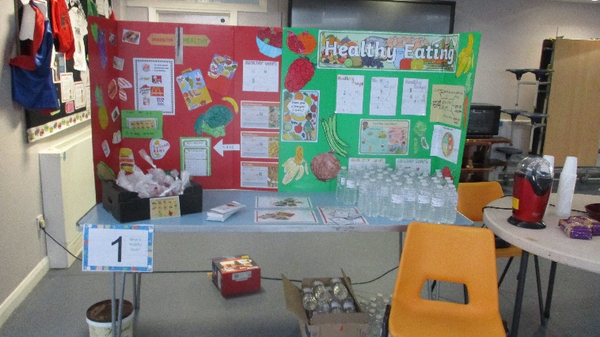

**Dahl Class, Healthy Eating**

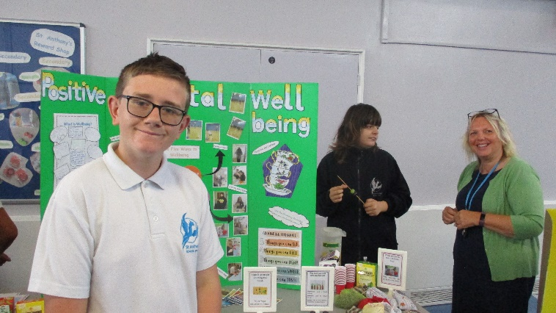

***Ryan, Kaleb & Jackie* guiding everyone through positive well being.**

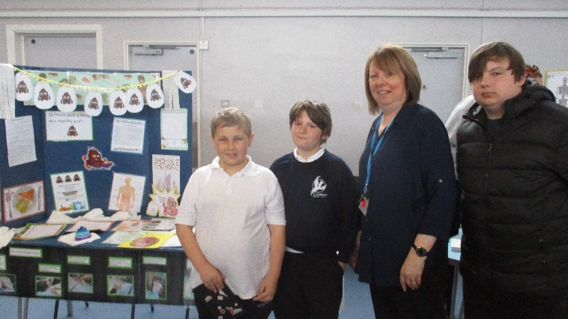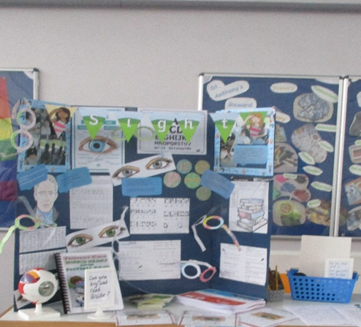  
**Potter Class, sight and seeing**

***Tom, Josh, Viv & Taylor*** answering questions on good gut health

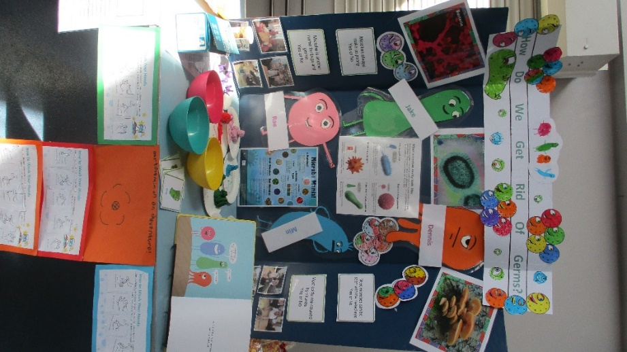

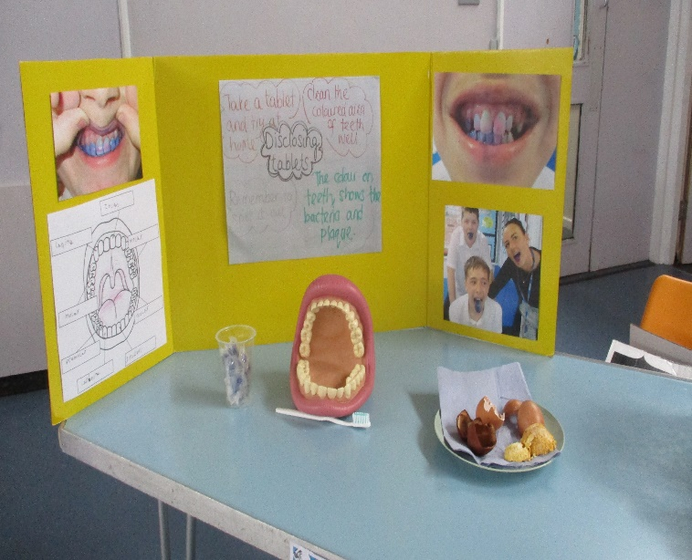**Milne Class, batteling the germs**

**Cowell Class, Teeth testing**

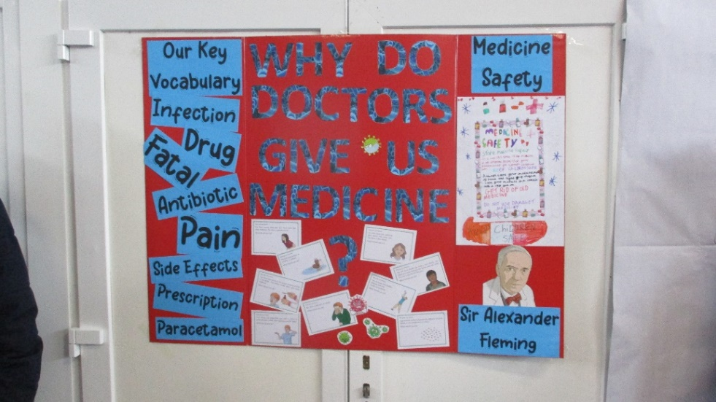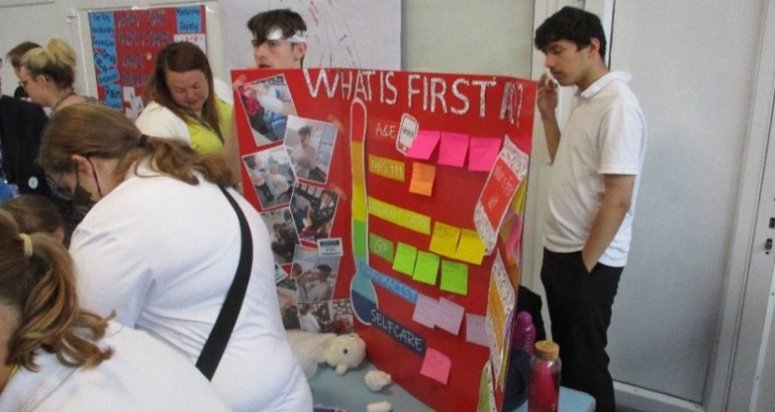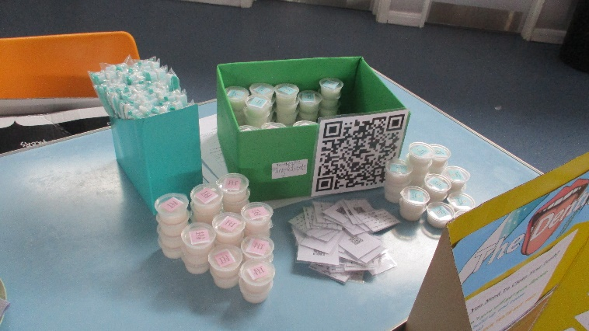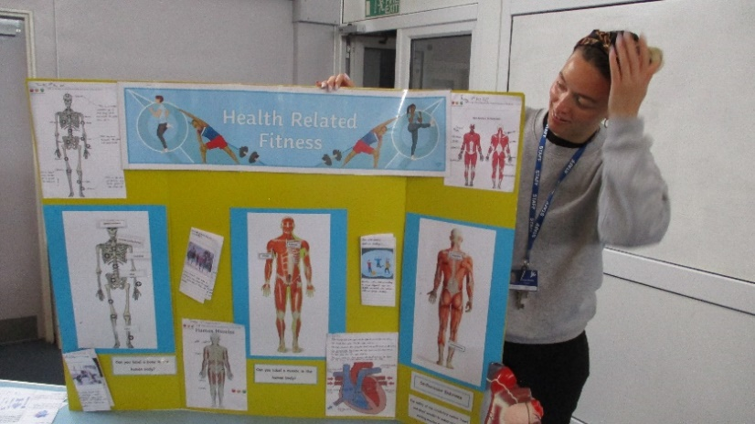

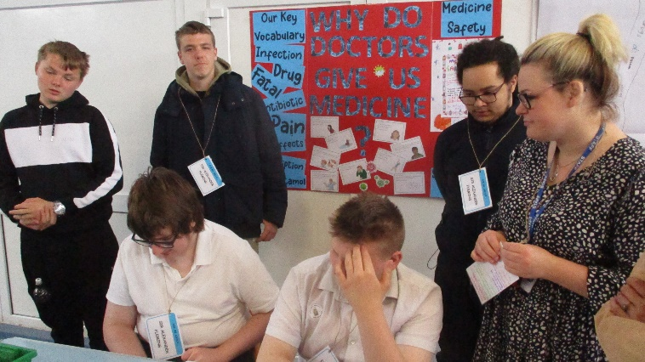

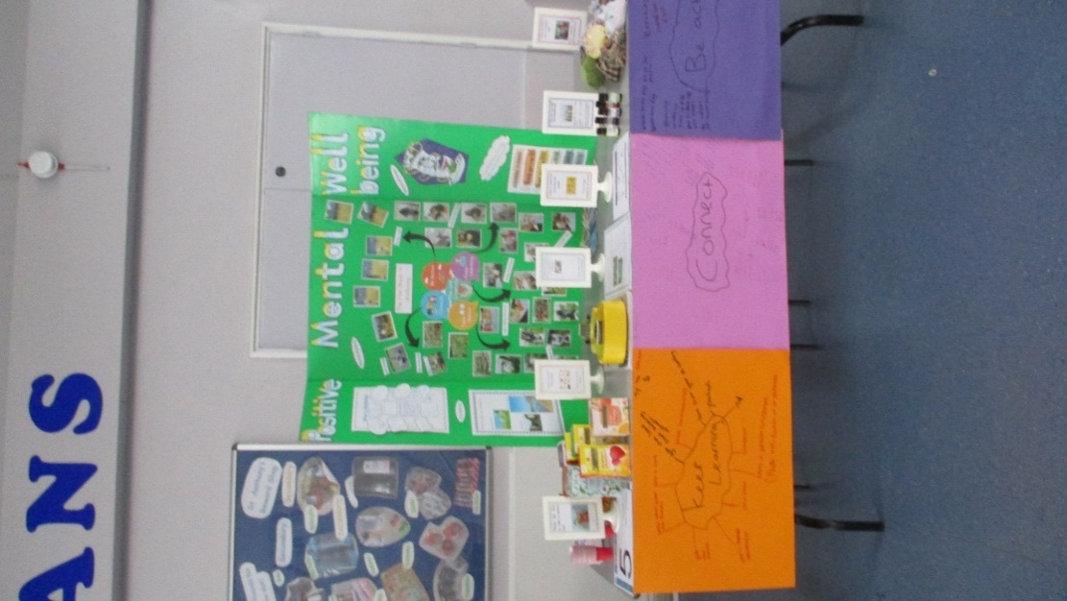

***Jayden, Jack, Bradley, Max, Brooklyn & Leanne explaining why Doctors prescribe medicine.***

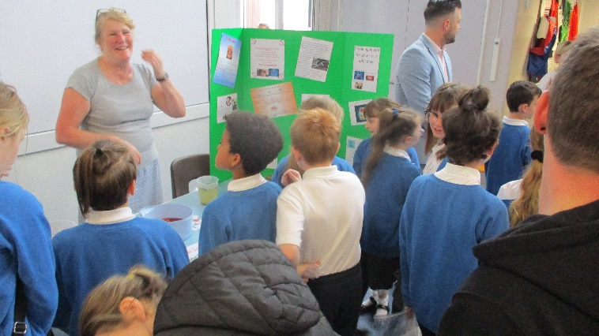

**Clayspace**

This term the KS4 Art students went to their second workshop at Clayspace. The first workshop in March was all about making something in clay. Some of the students made a sculpture, others such as ***Josh, Bradley*** and ***Beth*** created something useful such as a bowl, pot or a mug. ***Brooklyn*** did really well and created an ambitious vase during his making workshop. ***Logan*** created two Tarot cards to go with his current project, whilst ***Nicole*** created a clay tile inspired by the project title ‘Art Activism and Climate Change’. In their workshops this term all the students learnt about the different types of paint and glazes you can use to paint ceramic work with. Holly has been especially impressed with the students at Clayspace. Their work has now been dropped off at the school and is fantastic!

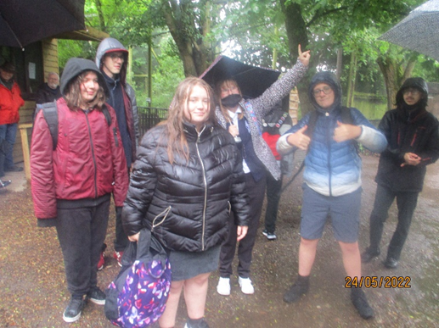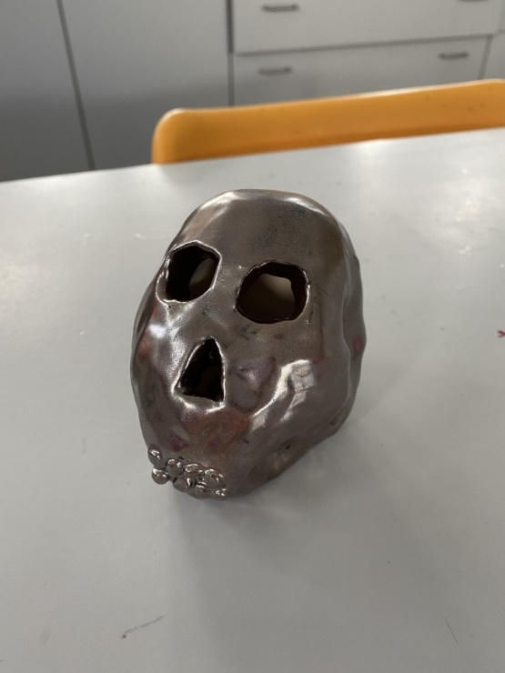

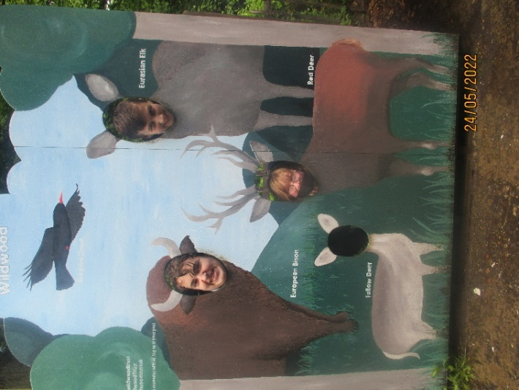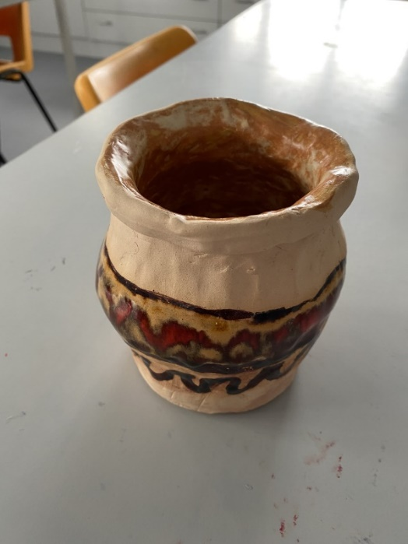

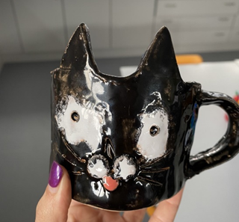

***Shay-Lee, Holly & Alfie* never missing a photo opportunity!**

**ART FESTIVAL 2022**

Margate Arts School is hosting this year’s Young Thanet Artists Festival, which has 17 entries from students at our school, some of whom have received commendations. Therefore, we would like to take this opportunity to invite all Parents, Carers and Family members to the exhibition, which has been extended by another week, from Monday 23rd May to Saturday 4th June. The Prize Presentation is on Saturday 4th June. There is over 600 paintings on display from 35 Thanet Schools and Colleges.

- Margate Arts School, 31-33 High St. -

**Viewing Times:**

Monday – Friday 10.00 am to 17.30 pm

Saturday – Sunday 10.00 am to 16.00 pm

**Further details can be found on:** [**www.facebook.com/thanetartsfestival**](http://www.facebook.com/thanetartsfestival)

**Rowling Wildwood Trip**

On Tuesday, **Rowling** Class visited Wildwood Trust. Although we got drenched from the rain when we arrived, the sun finally made an appearance, and we had a great day. Some students attempted the bridge and we watched the bears having a bath! The wolves were lively and the European Bison made us laugh!

***Daniel, Taylor, Deanna, Holly, Ryan & Prnjay* making the best of the fine British weather!**

**Dymchurch Railway Trip**

A group of pupils from across the school enjoyed a fantastic day out to Romney, Hythe and Dymchurch railway. The dedicated team of Drivers and Signallers shared the history and answered all the pupil's questions.  Whilst enjoying the train journey, we saw sheep and horses grazing in the fields and we had an ice cream at Dymchurch. An amazing day!



**Cricket**

**Rowling** attended the Thanet Inclusive Games to represent St Anthonys in Cricket, they took part in carousel of events in which they thoroughly enjoyed. There was a chance to practice, batting and fielding through-out the afternoon. ***Holly*** excelled in the batting whilst ***Alfie*** was deadly in the field. All in all a wonderful afternoon of cricket.

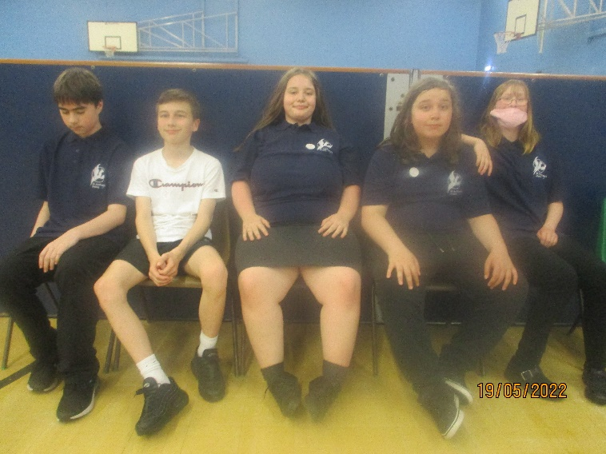

**Bailey, Alfie, Deanna, Daniel & Holly being good sports!**

**Kooth Mental Health - parent and carer webinars**

Kooth’s London and South-East team run a monthly parent and carer webinar. The sessions are designed to help parents and carers understand how Kooth can support their child with their mental health and wellbeing. The session covers:

* A Presentation on Kooth (which includes what to consider when wanting to have a conversation with their children about how they're feeling, etc.)
* A Live tour of the Kooth website
* An opportunity for Q&A about Kooth.

The dates and times are as follows:

* Tuesday 7 June from 6pm to 7pm
* Wednesday 27 July from 6pm to 7pm

If you have any questions, please email [parentsandcarers@kooth.com](mailto:parentsandcarers@kooth.com)

**Training, Personal Development Webinars**

Events – For Young People and/or Families

Kent Adult Educations new Skills Vocational provision is now live and ready to enroll! All

qualification are delivered via our new interactive and engaging platform for an enhanced learning experience.

Courses currently on offer include:

* Level 2 Certificate in Event Planning
* Level 2 Certificate in Behaviour that Challenges in Children
* Level 2 Certificate in Understanding Specific Learning Difficulties
* Level 2 Certificate in Understanding Autism

For further information please contact: [Skillsvocational@kent.gov.uk](mailto:Skillsvocational@kent.gov.uk)

**New Sports Club**

Thanet Wanders rugby club is running a new sports club for pupils with SEN on Tuesdays beginning next term. If you child has lots of energy go along.



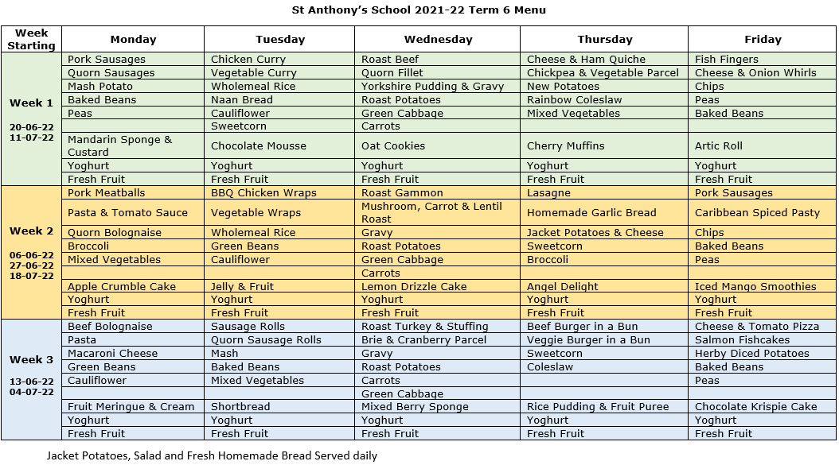

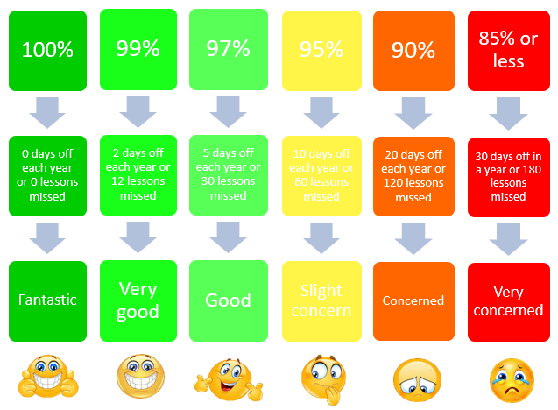

**Attendance explained…**

**5** minutes late each day = 3 days lost or 18 lessons*  
.  
**10** minutes late each day = 6.5 days lost or 39 lessons*  
.  
**15** minutes late each day = 10 days lost or 60 lessons*  
.  
**20** minutes late each day = 13 days lost or 78 lessons*  
.  
**30** minutes late each day = 19 days lost or 114 lessons*  
.  
 *\*figures calculated over an academic year*

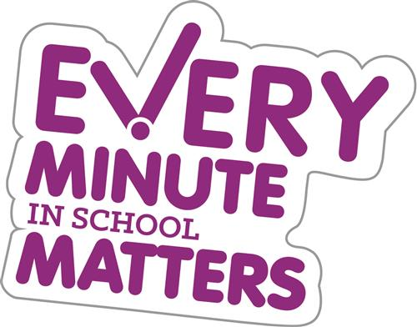



**Dates**

* Friday 27th May – Last Day term 5
* Monday 6th June – First Day term 6
* Friday 24th June Summer Fayre 5pm- 7 pm
* Thurs 7th July Sports Day (times TBC)
* Tues 19th July Reward Trips
* Thurs 21st July - **Last Day of term 6**   
   **1:30pm finish**



Visit [Kent Resilience Hub](https://kentresiliencehub.org.uk/) where you can increase your understanding, find approaches and tools or navigate your way to support and services relating to resilience and emotional wellbeing.



  
  
[Kooth online](https://www.kooth.com/) support and counselling for 10-25 year olds across Kent and Medway. Offering 1-2-1 counselling, helpful articles, community discussion boards and daily journals.





[MindEd](https://www.minded.org.uk/) is a free educational resource on children and young people's mental health for all adults.



Find out how to tackle hate online and online trolls with internet matters advice guide for what [online hate](https://www.internetmatters.org/resources/tackling-online-hate-and-trolling/) is and how to support your child.   
  
  
  
Get tools and tips to support your child’s [digital wellbeing](https://www.internetmatters.org/?gclid=EAIaIQobChMIrbTX5_bt7AIVRuztCh33bQH_EAAYASAAEgLtifD_BwE) on Facebook, Instagram and WhatsApp.



Call NSPCC on 0808 800 5000 if you’re worried about the safety of a child. Or call the police on 999 if you think a child is in immediate danger.



Mind's [Action for Children](https://minds.actionforchildren.org.uk/self-esteem) around self esteem and helping your child. Parents with Confidence help your child to emotionally regulate.

Free and confidential advice from [Family Lives](https://www.familylives.org.uk/how-we-can-help/confidential-helpline/) on 0808 800 2222 if you’re finding it hard at home with your child and are struggling to cope**.**  
  
  
[Young Minds](https://youngminds.org.uk/) have a parent’s helpline, information and resources.