**31st March 2023**

Happy Friday! We are now half way through term 5 already and what a term it has been, read on to see some of the things we have been up to.

**Dates for the diary**

* **Monday 8th March** – Bank Holiday for Kings Coronation
* **Friday 26th March** – Last day of Term 5
* **Monday 5th June -** 1st day of Term 6

**British Values**



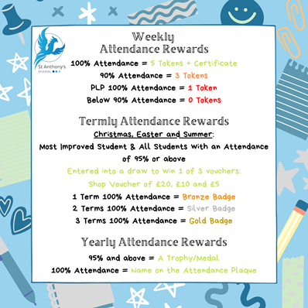**Attendance**Well done to all the children who consistently achieve a weekly attendance of 100%. We monitor attendance from Friday-Thursday allowing us to celebrate those children in our Friday Morning Assembly for their 100% attendance.   
Each child who achieves 100% attendance for the week gets a certificate and **5** tokens, any child who achieves 90% attendance will receive **3** tokens for the reward Shop.   
  
We also celebrate our students on a personal learning plan, these students are highly unlikely to achieve an attendance of 90% due to the nature of their timetable, therefore those students on PLP’s who attend 100% of their timetable that week will also receive a certificate and **1** token to spend in the reward shop.



**Coronation Celebration**

With the Coronation of His Majesty King Charles III and Her Majesty the Queen taking place on Saturday 6th May 2023 at Westminster Abbey. St Anthony’s held our own Coronation Celebration today (Friday 5th May 2023) to mark the very special occasion.

The children and adults enjoyed a street party style lunch with sandwiches, scones and other tasty treats. A feast fit for a King!

The children’s fun packed day started with an assembly to understand what a Coronation means and how the event will unfold. Each student received a commemorative mug to take home, followed by themed activities including crown making and cake decorating competitions in classes followed by the all-important Table Cloth Decorating Competition.

The winners were chosen by a special guest, Margates, Mayor Keen:

• ***Logan R*** won the crown competition  
• ***Cody C*** came first in the cake competition  
• ***Walliams class*** were awarded best tablecloth   
• ***Chris L*** took the prize of childs fancy dress  
• ***Katy Wr*** obtained the prize for adults best  
costume

Well done to all of the children (and adults) who took part, the cloths looked spectacular and will go down in history as a wonderful example of their creativity and team work.

Next on the agenda was face painting and an inflatable obstacle course, which really put the children’s coordination and team, working skills to the test once again.

Other special guests including Kent’s Fire Brigade team making a special appearance to celebrate with St Antony’s, the children were able to see a working Fire Engine and ask the fire team those all important questions they had.

With the scones scoffed and thirst’s quenched, it was time for the ice cream van to serve up some cool treats! No event is complete without a commemorative cake to cut. A big thank you to the cake and the difficult job of picking competition winners! Also a huge thank you to Tracey, Asda’s Community Fund Raiser for supporting funding towards the day, as well as the schools PTFA and the school.

Afternoon games were a success with children, staff, parents and friends of the school all joining in the array of games on offer including the coconut shy, hook a duck, tug of war, hoopla and splat the rat. What a wonderful turn out.

A wonderful day was had by all and would not have been possible without all the help from all the staff involved. A big thank you to Natalie and Jackie Benson for all their hard work and organization in making the day one to royally remember!

Everyone commented on how nice it was to get back together again. Here, here!  
  


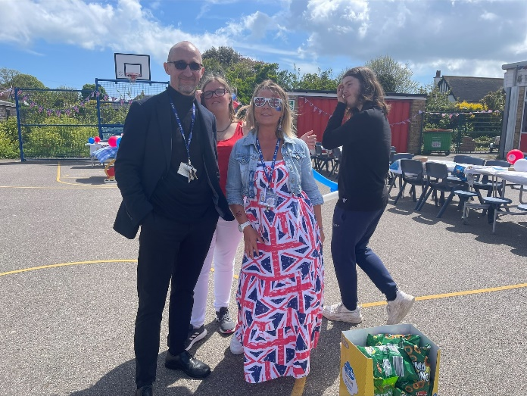

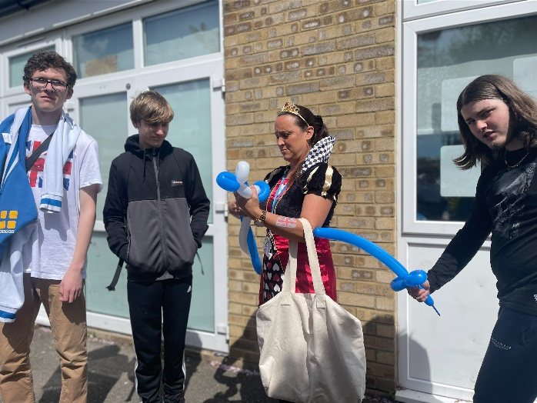

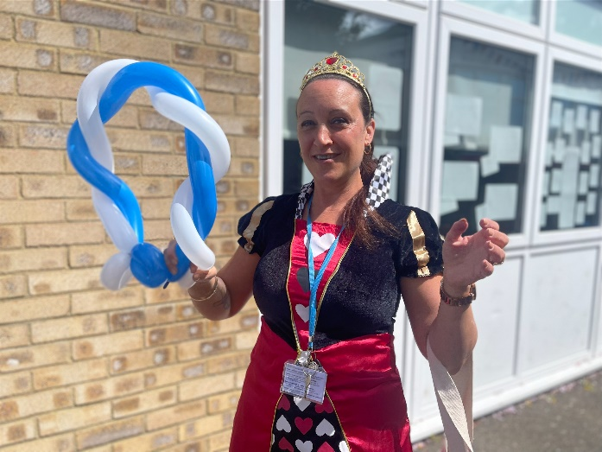



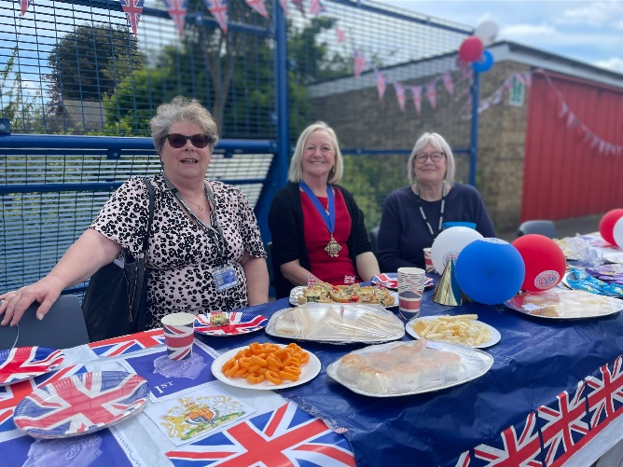







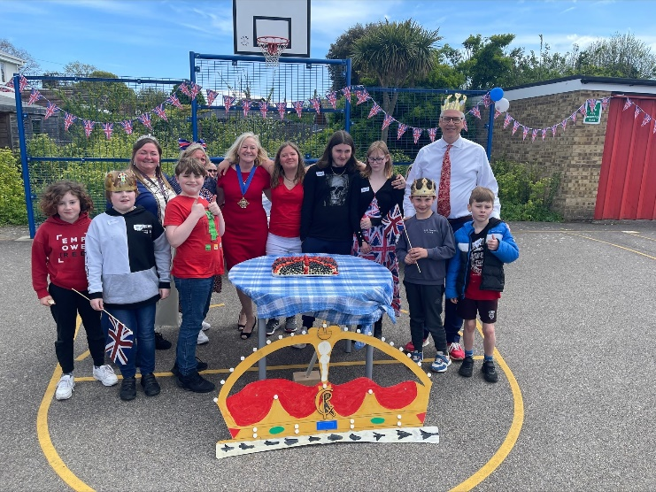

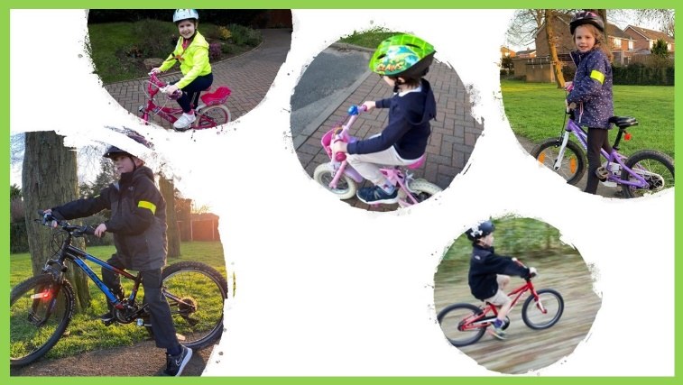

**Protecting** and **serving** the people of Kent

**NPCC 2 Wheel Week**

**As part of the National Police Chiefs Council “Two Wheel Week” running 17-23 April, in collaboration with KCC Bikeability trainers, Kent police would like to make you aware of some educational tips around cycling.**

**Cycling is a great way of getting to school and can keep you and your children healthy and active, but it can also present risks to your safety. Hopefully these tips will help you make sure you and your bike and ready to get cycling to school.**

* **Consider riding routes with dedicated cycle paths to ensure the safety of young children and pedestrians.**
* **Ensure that your bicycle is roadworthy. If it has been unused for a while, ensure that the mechanisms such as brakes and gears are working and that tyres are inflated before starting any ride.**
* **Always wear a cycle helmet regardless of where you are cycling. All child cyclists and scooter users should always wear a helmet.**
* **Wear Hi-Viz or bright colours to help other road users to see you. Red is particularly visible to road users.**
* **Think about your positioning in the road and whether you can be seen by other road users.**
* **Effectively communicate with other road users, by using hand signals when turning. Try to make eye contact with other road users and pedestrians to ensure that they have seen you.**
* **If approaching pedestrians from behind, use your bell or a polite verbal warning to alert them to your presence.**

**For more information about Bike Ability please see** [**Cycle training - Kent County Council**](https://www.kent.gov.uk/roads-and-travel/road-safety/road-safety-training/cycle-training)**.**

**We’d also like to take this opportunity to re-enforce the law around e-scooters. These are classed as Personal Light Electric Vehicles (PLEVs), which means they are treated as motor vehicles and subject to the same legal requirements, such as driving licence, insurance, number plates, lighting, road tax, crash helmets etc. Without these, e-scooters cannot be used legally on the road.**

**For more information about powered transporters and the law, visit** [**www.gov.uk**](http://www.gov.uk)

**We hope that these tips are of some use and help promote road safety.**

**Chief Inspector Craig West  
Head of Roads Policing**

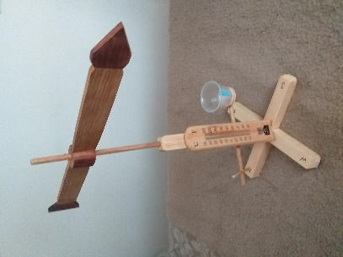

**DT Weather Stations**

This term Key Stage 4   
were tasked with making   
Weather Stations.

All made these independently   
just following a demo and   
drawing. A fantastic journey of skills and confidence learnt since September to enable them to concentrate and set themselves such high standard to want to achieve.  
  
This was so popular other year groups began to build their own too!  
 ***Kevin M, DT***

 ***Kaleb W, Taylor B, Ryan D & Ty V*** showing off their fantastic weather stations. Well done, boys!

**Whats on…**

**SPORT FOR FUN –** Saturdays (term time) 9.00 - 10.00 at St Anthony's School. A Saturday morning sports club for children with SEND.

**BE ACTIVE -SHORT BREAK** - Saturdays (term time) 10.30 - 12.00 at Foreland Fields School

**BE ACTIVE -SHORT BREAK** - Wednesdays (term time) 4.30 - 6.00 at Foreland Fields School

Please read the PDF letter attached for more information and complete the following referral form to declare interest:

<https://forms.office.com/r/EZwuMEZmEd>

**CLIP N CLIMB** - Thursdays Session 1: 4.30-5.30pm Session 2: 5.30-6.30pm.

To book please clink on this link: <https://forms.gle/EHYHiAtxWfE3XYDz6>

**MARGATE YOUTH FC KICKS 4 KIDS** - Tuesdays 5.00-5.45 at Margate FC

Inclusive football sessions delivered by Inclusive Sport. To register please visit: <https://www.margateyouthfc.co.uk/events/kick-inclusive-football-sessions>

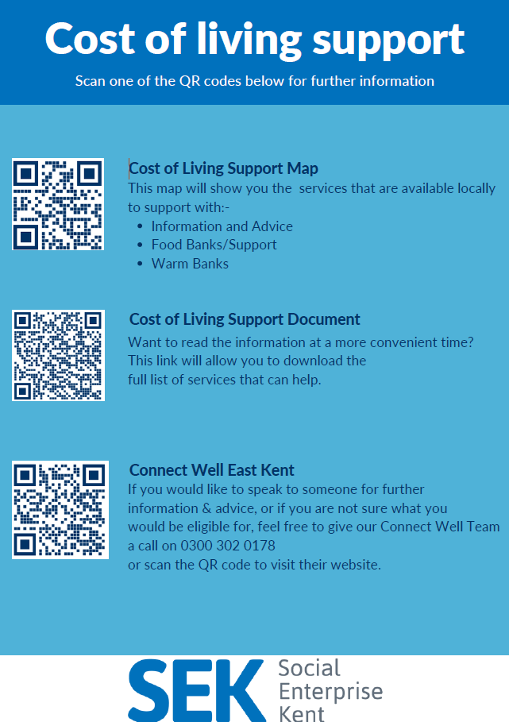

**Cost of Living Support**

With the pressures of costs around us there is a number of services that can support. If you are having troubles please contact them direct or come and talk with us.

A link below is Thanet councils community hub which can sign post to a range of support functions.

[**https://www.thanet.gov.uk/info-pages/covidcommunityadvice/**](https://www.thanet.gov.uk/info-pages/covidcommunityadvice/)

**DWP - Outreach sessions for families**

Outreach sessions are being held in local venues. Support on hand includes, benefit advice, childcare choices and cost, finding work, cost of living, housing and any queries that our work coach can support the family with.

**Ramsgate** – The Priory Children’s Centre, Cannon Rd, Ramsgate CT11 9SQ

Outreach available every Wednesday between 9am to 12noon To book a slot to see our adviser at the Priory Children Centre in Ramsgate please contact

[jayne.conroy@dwp.gov.uk](mailto:jayne.conroy@dwp.gov.uk)

**Margate**– Six Bells Children Centre, 201 High St, Margate CT9 1WH

Outreach available every Monday between 1pm to 4pm To book a slot to see our adviser at the Six Bells in Margate please contact

[philip.raeburn@dwp.gov.uk](mailto:philip.raeburn@dwp.gov.uk) or [anita.taylor@dwp.gov.uk](mailto:anita.taylor@dwp.gov.uk" \t "_blank)

**Royal British Legion - Energy Support**

The Royal British Legion, the UK's largest charity dedicated to supporting the Armed Forces community, has today launched a new grant scheme for veterans and their families who are struggling to pay their energy bills. The initiative will provide non-repayable emergency grants of up to £2,400 a year (£200 a month) and is available across the UK.

In general, the Armed Forces community includes those who have served, or are serving, in the Royal Navy, British Army or Royal Air Force, as well as their families, dependants and carers – which can include children, current and former spouses and partners, widows and widowers.

To apply it's worth [checking your eligibility on its website](https://eur01.safelinks.protection.outlook.com/?url=https%3A%2F%2Fwww.britishlegion.org.uk%2Fget-support%2Fwho-we-help&data=05%7C01%7CJenny.Hanna%40kent.gov.uk%7C0e5a983faa7040ba13ee08dab3399c0f%7C3253a20dc7354bfea8b73e6ab37f5f90%7C0%7C0%7C638019357270836664%7CUnknown%7CTWFpbGZsb3d8eyJWIjoiMC4wLjAwMDAiLCJQIjoiV2luMzIiLCJBTiI6Ik1haWwiLCJXVCI6Mn0%3D%7C3000%7C%7C%7C&sdata=3atnAtHJUwgEaZz76bOScnj82DDHbKKLWrCX4kciIcY%3D&reserved=0) or by calling its helpline on 0808 802 8080.



Visit [Kent Resilience Hub](https://kentresiliencehub.org.uk/) where you can increase your understanding, find approaches and tools or navigate your way to support and services relating to resilience and emotional wellbeing.

[Kooth online](https://www.kooth.com/) support and counselling for 10-25 year olds across Kent and Medway. Offering 1-2-1 counselling, helpful articles, community discussion boards and daily journals.

****[MindEd](https://www.minded.org.uk/) is a free educational resource on children and young people's mental health for all adults.

Find out how to tackle hate online and online trolls with internet matters advice guide for what [online hate](https://www.internetmatters.org/resources/tackling-online-hate-and-trolling/) is and how to support your child. Get tools and tips to support your child’s [digital wellbeing](https://www.internetmatters.org/?gclid=EAIaIQobChMIrbTX5_bt7AIVRuztCh33bQH_EAAYASAAEgLtifD_BwE) on Facebook, Instagram and WhatsApp.

Call NSPCC on 0808 800 5000 if you’re worried about the safety of a child. Or call the police on 999 if you think a child is in immediate danger.

Mind's [Action for Children](https://minds.actionforchildren.org.uk/self-esteem) around self esteem and helping your child. Parents with Confidence help your child to emotionally regulate.

Free and confidential advice from [Family Lives](https://www.familylives.org.uk/how-we-can-help/confidential-helpline/) on 0808 800 2222 if you’re finding it hard at home with your child and are struggling to cope**.**[Young Minds](https://youngminds.org.uk/) have a parent’s helpline, information and resources.