Friday 13th May 2022 Newsletter

Happy Friday all! We continue to bask in lovely sunny weather though it would be nice to have some more warmth. It has been another busy fortnight here at school as you will read.
As we come to the end of term 5 our Year 11 pupils start to think of leaving us, as they complete their qualifications and their formal studies. Before work experience placements in term 6.
An issue that l would like to bring to parents and carers attention is your child’s attendance. The school overall attendance figure is very low, so l would like your support to improve this in term 6. The figure has been significantly impacted this year by COVID but with cases now reduced we would like to see pupils attending school every day now to the end of the school year.
In assembly this week we announced a competition to encourage pupils attendance, please ask them about it.
Watch this space as we will be sharing more information with you about why school atttendance is so important.

Science Week 16th – 20th May
Next week is Science Week at school. Pupils will be doing a wide range of science activities. The theme for Science Week is All About Healthy Me!
The week will end with a science fayre on Friday 20th May, pupils’ families are welcome to come.
Doors open: 09:15 till 10:30 am
Kooth Mental Health - parent and carer webinars
Kooth’s London and South-East team run a monthly parent and carer webinar. The sessions are designed to help parents and carers understand how Kooth can support their child with their mental health and wellbeing. The session covers:
• A Presentation on Kooth (which includes what to consider when wanting to have a conversation with your child about how they're feeling, etc.)
• A Live tour of the Kooth website
• An opportunity for Q&A about Kooth.

The dates and times are as follows:
Tuesday 7 June
6pm to 7pm
Wednesday 27 July
6pm to 7pm

If you have any questions, please email parentsandcarers@kooth.com

Work Experience
One of the goals of school is to prepare pupils for work. To help pupils with this we look at different career options for them in lessons leading up to our Year 11 pupils having a two-week work experience placement in June.
If pupils have a particular interest we also try to set up opportunities before then. Marshall expressed to me an interest of wanting to be an Estate Agent when leaving school. So after a few phone calls Marshall was offered a work experience placement with the estate agents Miles & Barr which started in February. He has since been going ‘to work’ each Friday 10-12.
He has been taken out on house viewings and has also been on house valuation visits too. Marshall has also been shown how house details are organised ready to be placed on the internet.
Marshall has really enjoyed the experience and I have received very positive feedback from Miles & Barr.
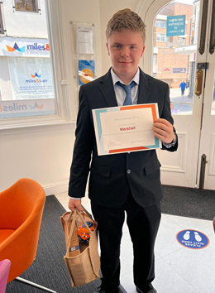
Marshall has also received 'Employee of the Month' Award
I am very proud of Marshall on what he has achieved and he has been an excellent ambassador for St Anthony's School.
Well done Marshall
Matt
Boxing
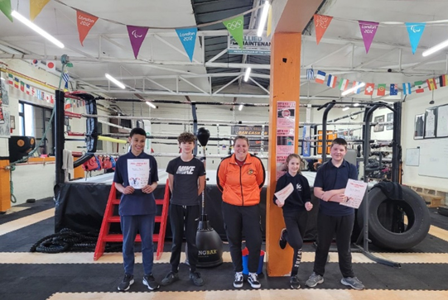
Four more of our great students passed the Preliminary Boxing Course! After completing the 10 week course, they were assessed yesterday. They showed discipline, determination and resilience throughout. This was not an easy course, we had our ups and downs, but Isaac, Adam, Sophie and Fraser worked very hard and walked away with their certificates feeling proud.
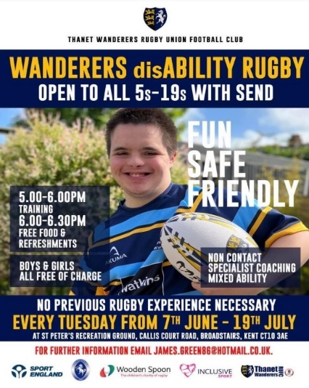
Michela’s New Sports Club

Thanet Wanders Rugby Club is running a new sports club for pupils with SEN on Tuesdays beginning next term. If your child has, lots of energy go along.

Hard Working Staff
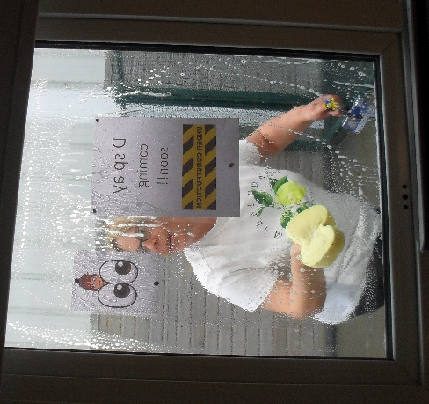
If you need your windows cleaning then give us a call!

Dates for the Diary
Friday 27th May - Last Day term 5

Monday 6th June - First Day term 6

Friday 24th June - Summer Fayre 5pm- 7 pm

Friday 1st July - Sports Day

Thurs 21st July - Last Day of term 6

Visit Kent Resilience Hub where you can increase
your understanding, find approaches and tools or navigate your way to support and services relating
to resilience and emotional wellbeing.

Kooth online support and counselling for 10-25 year olds across Kent and Medway. Offering 1-2-1 counselling, helpful articles, community discussion boards and daily journals.

MindEd is a free educational resource on children and young people's mental health for all adults.

Find out how to tackle hate online and online trolls with internet matters advice guide for what online hate is and how to support your child. Get tools and tips to support your child’s digital wellbeing on Facebook, Instagram and WhatsApp.

Call NSPCC on 0808 800 5000 if you are worried about the safety of a child. Or call the police on 999 if you think a child is in immediate danger.

Mind's Action for Children around self-esteem and helping your child. Parents with Confidence help your child to emotionally regulate.

Free and confidential advice from Family Lives on 0808 800 2222 if you are finding it hard at home with your child and are struggling to cope.

Young Minds have a parent’s helpline, information and resources.

