17th June 2022 Newsletter

I hope that this email finds you all well and that you are enjoying the wonderful weather we are having.
We have began Term 6 celebrating Art Week, with trips to the Turner Contemporary and Graffiti workshops in school.
Our Year 11 pupils have been doing work experience at a range of placements at schools, kitchens, library and Revolution. Next week we say goodbye to them at their Leaver’s assembly and Leaver’s trip.
Next Friday 24th June at 5pm is the Summer School Fayre, which will be the first Fayre in a couple of years and l hope to see lots of you attend. If one can trust the long range BBC weather forecast it should be perfect weather.
Robert Page

Dates
- Friday 24th June - Summer Fayre 5pm- 7 pm
- Friday 8th July - Sports Day Times TBC
- Tues 19th July - Reward Trips
- Thurs 21st July - Last Day of term 6 1:30 finish

Arts Week
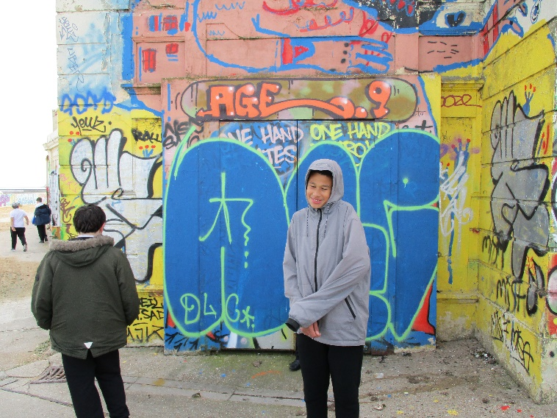
Last week was Arts Week and a large number of students went on trips to see some art outside of school. Milton and Year 10 pupils went to see the street art on Margate beach near the lido, to support their spray painting artwork in school. They also went to the games room in the Turner Contemporary which was curated by the artist Larry Achiampong whose work is exhibited there and is inspired by video games. All of KS2 are off to the Turner Contemporary to have either a sensory or making workshop inspired the artwork in the gallery. All trips were finished off with chips on the beach from Pete’s Fish Factory!
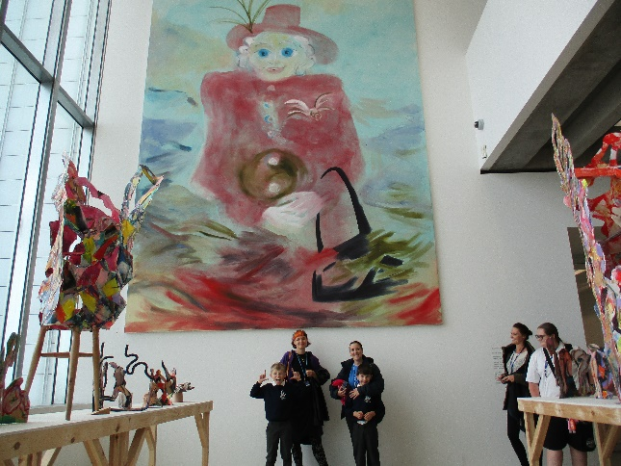
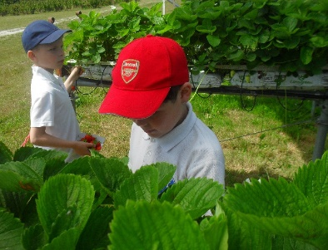
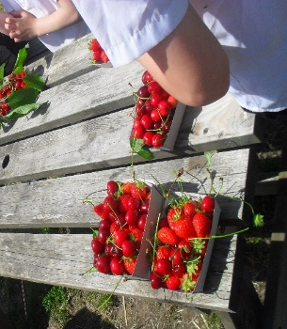
This week all of KS3 had three full days of a Graffiti art workshop, delivered by graffiti artists. They created a permanent display that will be displayed in the sports hall. Photos of this will be in the next newsletter!
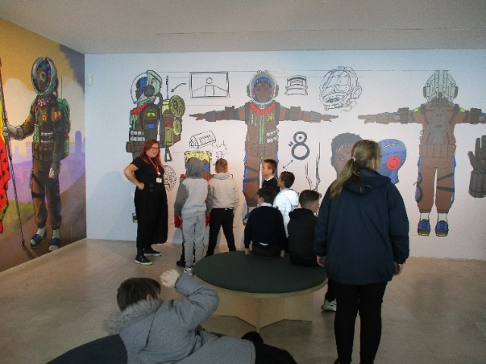
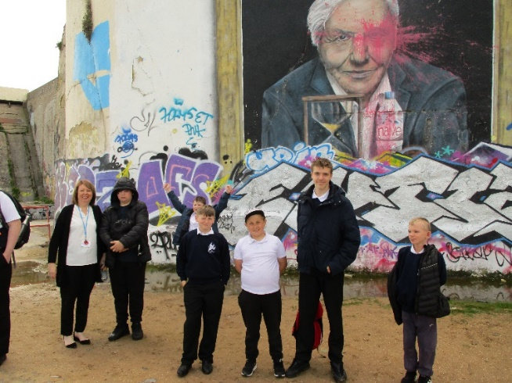
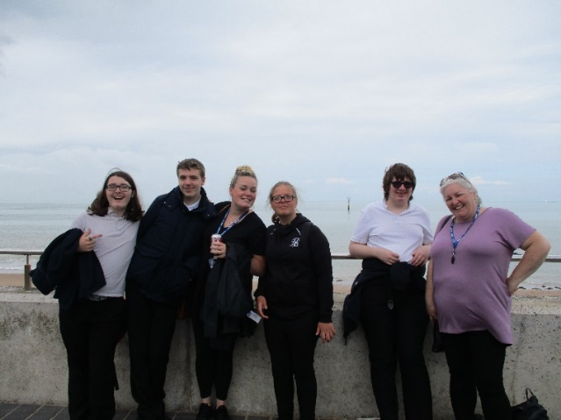
Strawberries
Blyton and Cowell went Strawberry Picking this week at Felderland Farm in Sandwich. As well as enjoying the sunshine we were able to take some of the local produce back with us!

All of the children thoroughly enjoyed their time and even got to learn all aout the process of growing strawberries on the farm.

New Sports Club
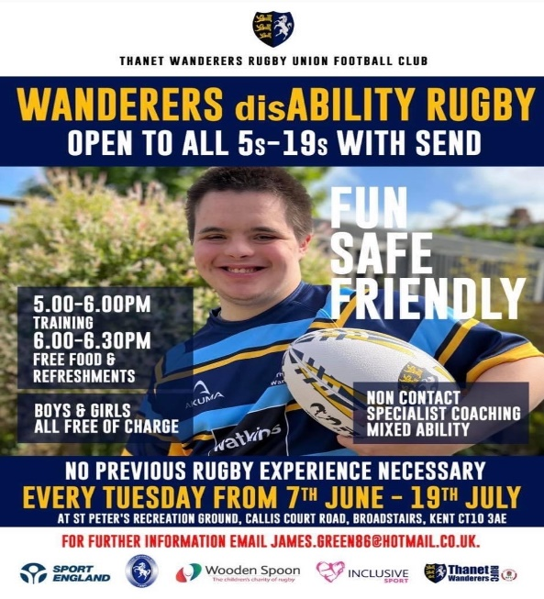
Thanet Wanders rugby club is running a new sports club for pupils with SEN on Tuesdays beginning next term. If you child has lots of energy go along.

Training, Personal Development Webinars
Events – For Young People and/or Families
Kent Adult Educations new Skills Vocational provision is now live and ready to enroll! All
qualification are delivered via our new interactive and engaging platform for an enhanced learning experience. Courses currently on offer include:
Level 2 Certificate in Event Planning
Level 2 Certificate in Behaviour that Challenges in Children
Level 2 Certificate in Understanding Specific Learning Difficulties
Level 2 Certificate in Understanding Autism
For further information please see the attached posters or contact
Skillsvocational@kent.gov.uk

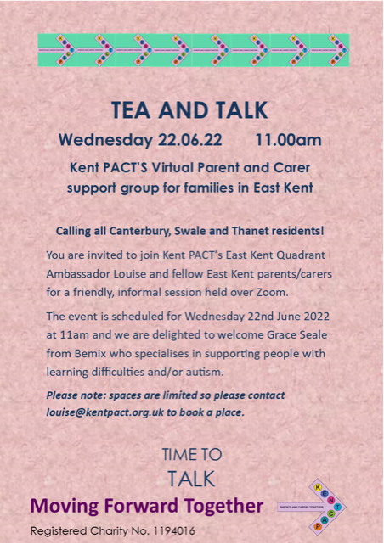
A reminder for parents and carers of the importance of routine immunisations for your teens

The national routine childhood immunisation programme has a direct positive impact on the health and wellbeing of children and communities and is vital to reduce the spread of infection and prevent outbreaks.

In addition to the flu and COVID-19 vaccines that have been offered to school-aged children this academic year, teenagers are routinely offered 3 vaccines in secondary schools:

human papillomavirus (HPV) vaccine Yr 8 and 9
menACWY vaccine in Year 9
Td/IPV (3-in-1 booster) in Year 9

The delivery of these routine adolescent immunisation programmes has been significantly impacted by the COVID-19 pandemic and vaccine coverage is still not at pre-pandemic levels. The UK Health Security Agency (UKHSA) and NHS England and NHS Improvement (NHSEI) are reminding parents and carers about the important protection these immunisations provide. They are also encouraging take up and catch up of vaccinations for anybody who has missed out.
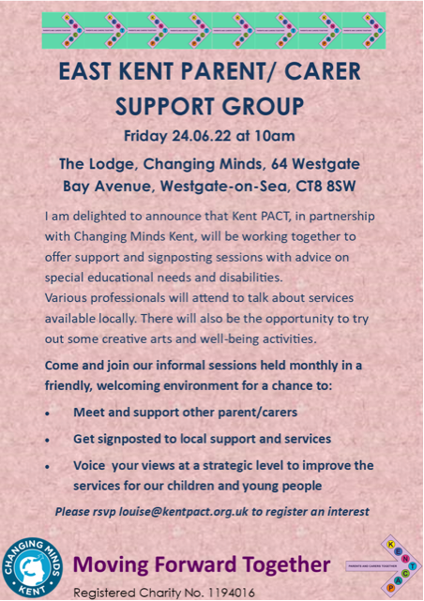

Education and childcare settings have a vital role to play in supporting the routine immunisation programme. It would be very helpful for settings to share information with parents. Further information can be found in the UKHSA immunisation guidance.

A wide range of immunisation support resources for educational settings are available which can be shared with parents. They can be ordered on the health publications website or by calling 0300 123 1002. For further information, please email immunisations@phe.gov.uk

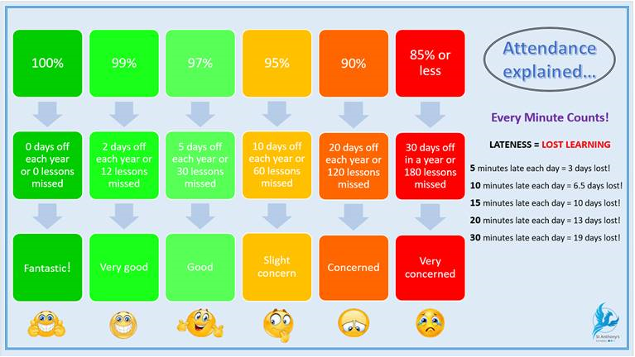
Visit Kent Resilience Hub where you can increase your understanding, find approaches and tools or navigate your way to support and services relating to resilience and emotional wellbeing.

Kooth online support and counselling for 10-25 year olds across Kent and Medway. Offering 1-2-1 counselling, helpful articles, community discussion boards and daily journals.

MindEd is a free educational resource on children and young people's mental health for all adults.

Find out how to tackle hate online and online trolls with internet matters advice guide for what online hate is and how to support your child. Get tools and tips to support your child’s digital wellbeing on Facebook, Instagram and WhatsApp.

Call NSPCC on 0808 800 5000 if you’re worried about the safety of a child. Or call the police on 999 if you think a child is in immediate danger.
Mind's Action for Children around self-esteem and helping your child. Parents with Confidence help your child to emotionally regulate.

Free and confidential advice from Family Lives on 0808 800 2222 if you’re finding it hard at home with your child and are struggling to cope.

Young Minds have a parent’s helpline, information and resources.

