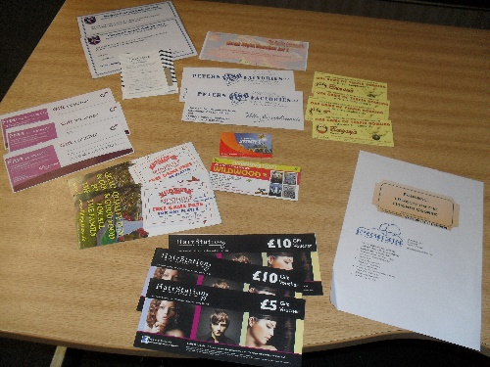
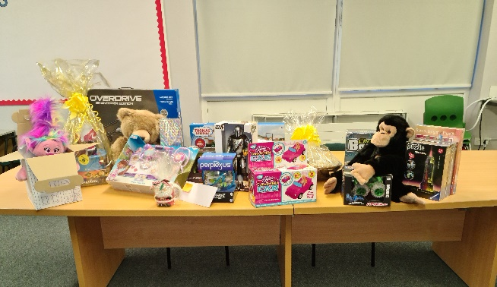

St. Anthony’s Winter Raffle – tickets on sale now. Please send money in to the school office with a contact name and number - £1 a strip.
Draw to be done virtually on 14th December at 2.45pm.
Prizes
- Thomas Train Set – donated by Hornby Hobbies
- The Racing Greyhound – steak night voucher for 2
- Hamper – donated by Morrisons
- Wildwood voucher for 2 people
- Stagecoach – megarider card
- Peter’s Fish Factory – 2 x 2 meals of your choice.
- Lillyputt Mini Golf – 2 x 2 people games
- Margate Football Club – 2 x family of 5 match passes
- The Salon at Broadstairs College – 3 vouchers
- Stonelees Golf – voucher for Fourball 18 holes on Heights Course
- HairStation – £25 voucher
- Bugsy’s Bowling – 4 games vouchers
- Waitrose - £15 voucher
- Bottle of Whisky – donated by Jack Burgham’s family
- 3 jigsaws
- Overdrive Grand Prix
- Laura Ashley Toiletries Hamper – made by Jackie Draper
- Gorilla cuddly toy – donated by Keel Toys/George Chaplin
- Large teddy bear – donated by Keel Toys/George Chaplin
- Chrono Bomb game
- Flipover car
- Robo Flyer
- Convertible car
- Star Wars figure – The Mandalorian
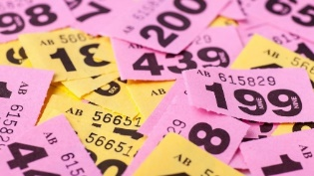
- Perplexus puzzle

