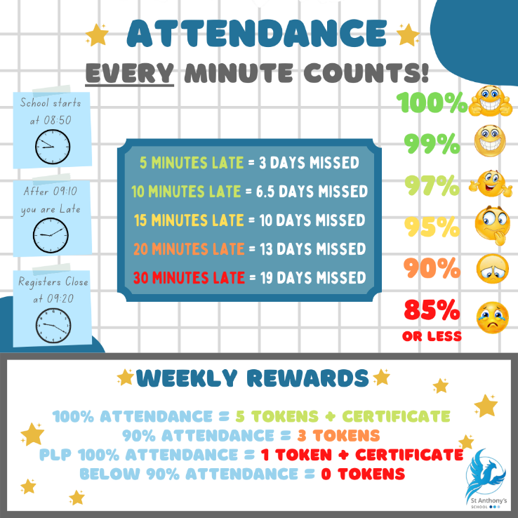**1st March 2024**

Welcome back, l trust you all enjoyed a good break.

You may have seen on social media posts about the recruitment of a new headteacher for St Anthony’s. It is true that I shall be retiring as the Headteacher of St Anthony’s School at the end of this academic year. At which stage l will have completed 9 years as Head l, after the previous 5 years as Deputy Head and Head of Primary. A position that not only I have enjoyed immensely, but which has been a privilege to hold. The recruitment of a new headteacher is ongoing and l will keep you informed of the governor’s decision to appoint a new headteacher.

I am looking forward to the rest of the year at St Anthony’s and hope that during the course of it to continue to support the school across Kent. I shall always regard it as an absolute privilege that I have been able to work at such an inspiring special school, a unique provision that has supported and provided excellent opportunities for countless children. The children and young people have taught me so much and I owe a depth of gratitude to them and their families as well as the excellent staff and governors that I have had the pleasure to have worked with.

This newsletter highlights the wide range of activities pupils have the opportunity to experience so read on.   
 ***Robert Page, Head Teacher***  
**Dates for the diary**

* **Thursday 7th March –** World Book Day
* **Friday 15th March –** Red Nose Day
* **Thursday 28th March –** Last day of Term 4

**British Values**

* **Democracy** - have the right to have your voice heard
* **Individual Liberty** - Promote freedom of choice
* **Rule of Law** - The importance of law and rules
* **Mutual Respect & Tolerance** - to respect those from different backgrounds

**Attendance**Did you know your child’s attendance affects your child’s success? Being in school, on time, every day is vital for student’s well-being, not just their educational growth but for their development in so many other areas such as social and emotional development. We understand that our students needs are far different from the students in mainstream school, so this year we are aiming for a whole school attendance of at **least 85%.** To achieve this, we are continuing our promotion and praise of individual school attendance.

**How is Attendance at St Anthony’s rewarded?**

We monitor and reward attendance on a weekly, termly and yearly basis with a variety of rewards up for grabs. Our weekly attendance is monitored from a Friday to a Thursday, this allows us to celebrate that week’s attendance achievements in our school assembly on a Friday morning.

Students who obtain 100% attendance from the Friday to Thursday will receive a certificate and 5 Reward Shop Tokens. Students who receive 90% attendance in the same period will receive 3 Reward Shop Tokens. We also recognise that our students who have a Personal Learning Plan (or a PLP) will never obtain 100% or 90% attendance due to their learning plan. Therefore, students on a PLP who attend 100% of their PLP during the weekly time-frame are rewarded with a certificate and 1 Reward Shop Token.

The Termly monitoring is based upon the old 3 term school year, Term 1 running until Christmas, Term 2 until Easter and Term 3 until Summer. For every student who achieves 100% attendance for the Term will receive a pin badge and a certificate. The colour of the pin badge is determined by how many TERMS the student has achieved 100%. Bronze will be awarded for all students who have achieved 1 Term of 100% attendance. Silver is awarded to all students who have achieved 2 TERMS of 100% attendance and Gold is awarded to all students who have achieved all 3 TERMS of 100% attendance. Also, ALL students with an attendance of 95% or above will be entered into a draw to win 1 of 3 vouchers worth £20, £10 and £5.

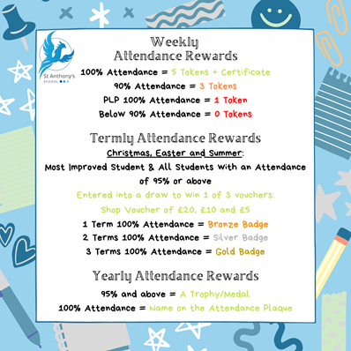The Yearly monitoring is quite simple, all students who receive 95% attendance or above will be presented with a certificate and medal. Students who receive 100% attendance for the year will receive a certificate and medal to take home and their name will be etched onto our Attendance Plaque.

 **Thursday 7th March 2024**

**World Book Day** class competition this year is for the best 'Story Sack'!

Story Sacks take popular children's books and add props and prompts.

The Story Sacks will then be used in our Key Stage 2 to continue to promote the love of reading.

If pupils want to dress up on the day as a book character they can, prizes will be given!

**Red Nose Day**



This year we will be doing activities in class to mark Red Nose Day. This will focus on looking at the work of **Sir Lenny Henry**, who is leading the day for the last time.



The day itself **(Friday 15th March)** will be **non-uniform** in exchange for a small monetary contribution, which we will donate it to the Comic Relief charity.

We will not be selling red noses, but they can be worn on the day, if you have bought your own.

You can buy noses and other RND products from:

* TK Maxx & Homesense
* Amazon
* Holland & Barrett

**Ashanti – The therapy dog**

We are really excited to introduce Ashanti who is going to working with the school as our therapy dog. Ashanti is a Golden Doodle and he is two years old. He will be visiting school every week with his owners Jo and Ian. He will be helping to support the children in different ways. After an initial introduction and children get to know Ashanti, they will be able to read to him, take him for a walk around school or just sit and play with him. Hopefully parents and families will get the chance to meet Ashanti as he will hopefully be able to join us on special occasions such as the school fair. We know there will be lots of excitement to meet Ashanti, but we also know dogs are not for everyone, so please just let the office know if your child does not want to be included in meeting and working with Ashanti.



**DT Hornby Visit**The students who attend DT after school club where treated to a visit to the new refurbished Hornby Centre.   
Whilst there, Kevin found out that Sophie took a keen intertest in the Armoured Car. Adam, Taylor and Thomas A all share a passion for the 007 Bike used in No Time to Die. Old toys from the 70s, especially Star Trek and Dr Who were also firm favourites amongst the boys.

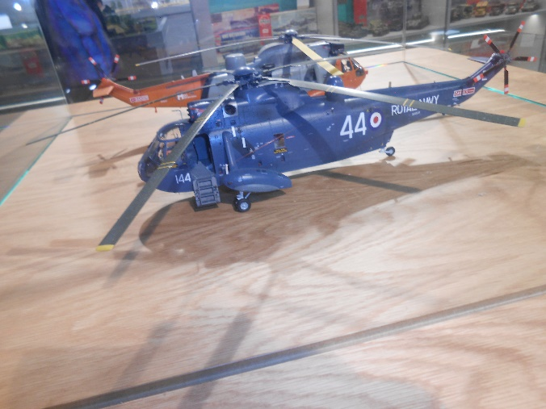Ty has an overall enthusiasm for all things Hornby as he has shown during his time in DT Class & after school club. 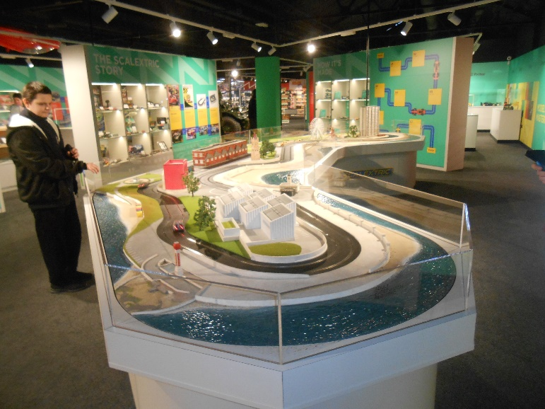  
  
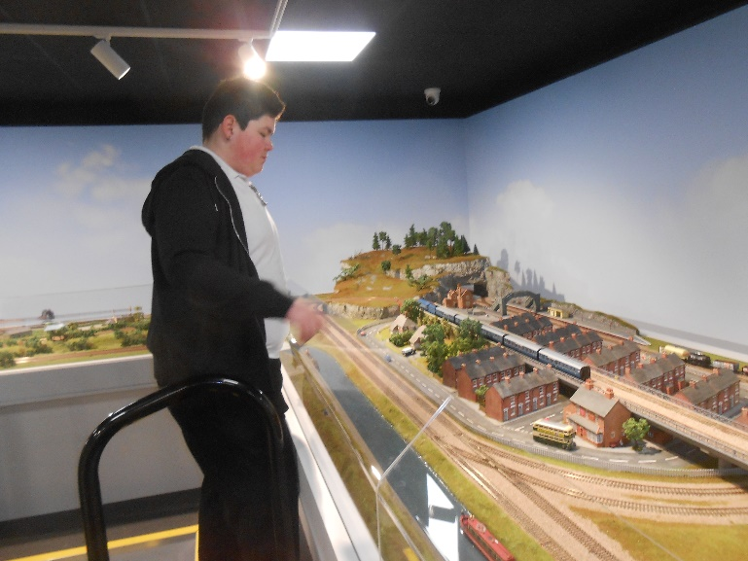  
 **Go Alfie!**

We are so proud of Alfie who received the most outstanding new recruit award at Margate Sea Cadets annual awards night last Saturday

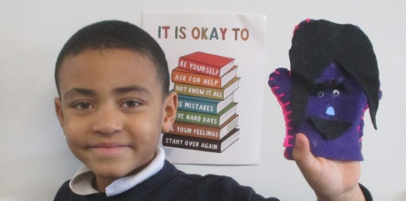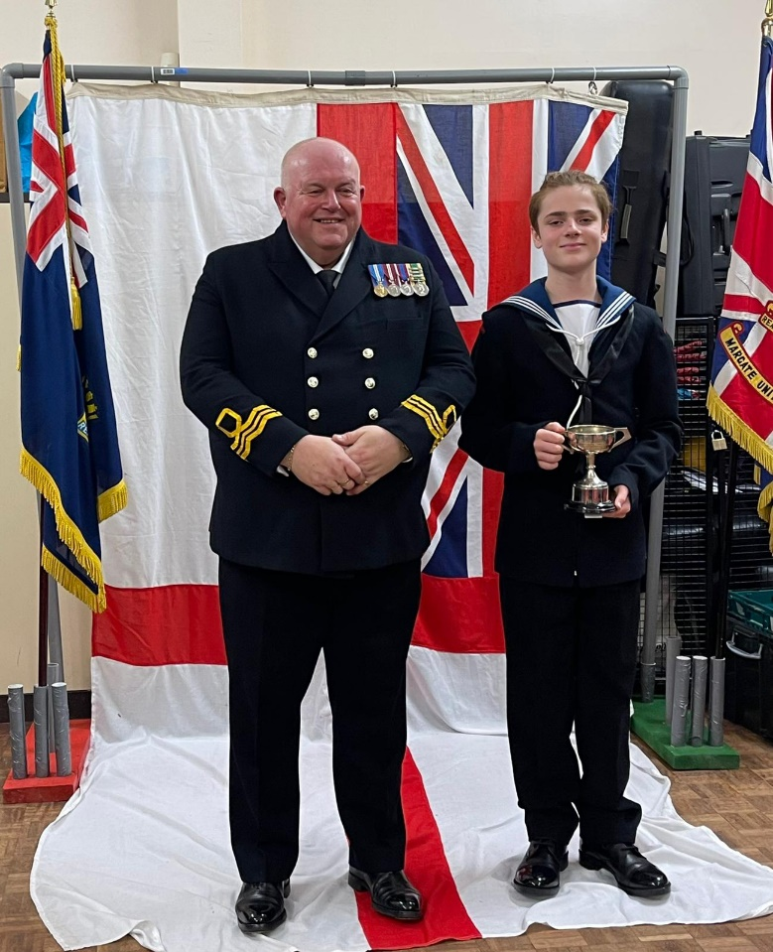 **Pegwell Sewing success!**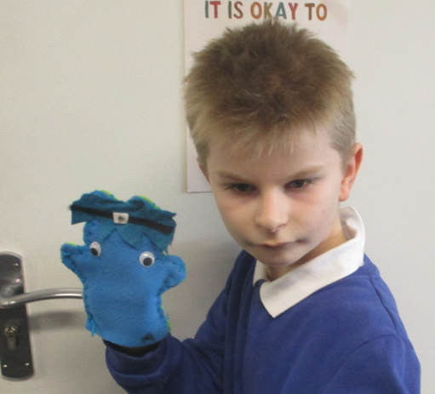

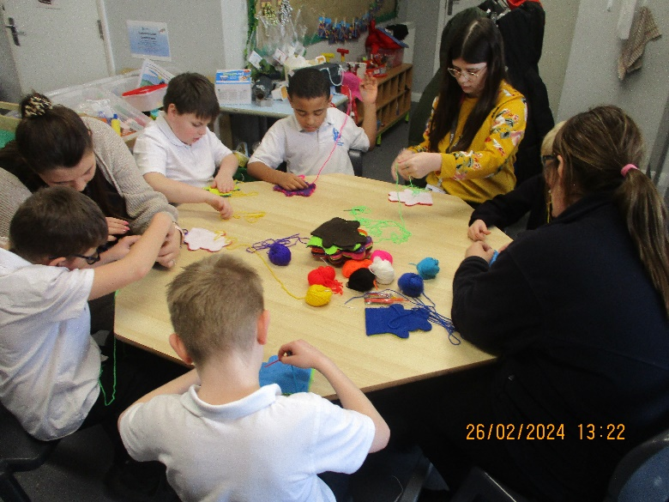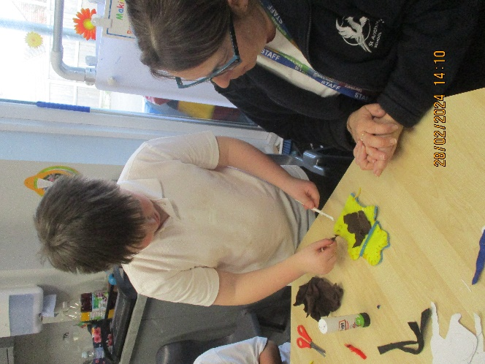

**Whats on…**

**SPORT FOR FUN –** Saturdays (term time) 9.00 - 10.00 at St Anthony's School. A Saturday morning sports club for children with SEND.

**BE ACTIVE -SHORT BREAK** - Saturdays (term time) 10.30 - 12.00 at Foreland Fields School

**BE ACTIVE -SHORT BREAK** - Wednesdays (term time) 4.30 - 6.00 at Foreland Fields School

complete the following referral form to declare interest: <https://forms.office.com/r/EZwuMEZmEd>

**CLIP N CLIMB** - Thursdays Session 1: 4.30-5.30pm Session 2: 5.30-6.30pm.

To book please clink on this link: <https://forms.gle/EHYHiAtxWfE3XYDz6>

**MARGATE YOUTH FC KICKS 4 KIDS** - Tuesdays 5.00-5.45 at Margate FC   
Inclusive football sessions delivered by Inclusive Sport. To register please visit: <https://www.margateyouthfc.co.uk/events/kick-inclusive-football-sessions>   
 **Cost of Living Support**

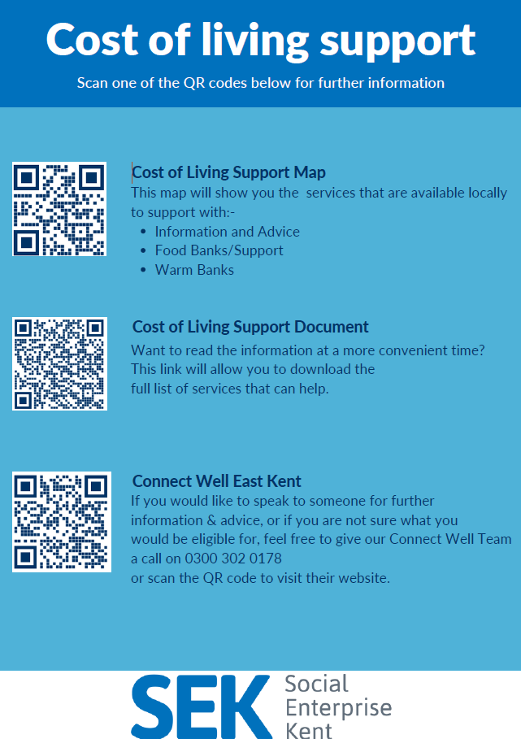

With the pressures of costs around us there is a number of services that can support. If you are having troubles please contact them direct or come and talk with us.

A link below is Thanet councils community hub which can sign post to a range of support functions.

[**https://www.thanet.gov.uk/info-pages/covidcommunityadvice/**](https://www.thanet.gov.uk/info-pages/covidcommunityadvice/)

**DWP - Outreach sessions for families**

Outreach sessions are being held in local venues. Support on hand includes, benefit advice, childcare choices and cost, finding work, cost of living, housing and any queries that our work coach can support the family with.

**Ramsgate** – The Priory Children’s Centre, Cannon Rd, Ramsgate CT11 9SQ

Outreach available every Wednesday between 9am to 12noon. To book a slot to see our adviser at the Priory Children Centre in Ramsgate please contact [jayne.conroy@dwp.gov.uk](mailto:jayne.conroy@dwp.gov.uk)

**Margate**– Six Bells Children Centre, 201 High St, Margate CT9 1WH

Outreach available every Monday between 1pm to 4pm. To book a slot to see our adviser at the Six Bells in Margate please contact

[philip.raeburn@dwp.gov.uk](mailto:philip.raeburn@dwp.gov.uk) or [anita.taylor@dwp.gov.uk](mailto:anita.taylor@dwp.gov.uk)

Visit [Kent Resilience Hub](https://kentresiliencehub.org.uk/) where you can increase your understanding, find approaches and tools or navigate your way to support and services relating to resilience and emotional wellbeing.

****[Kooth online](https://www.kooth.com/) support and counselling for 10-25 year olds across Kent and Medway. Offering 1-2-1 counselling, helpful articles, community discussion boards and daily journals.  
[MindEd](https://www.minded.org.uk/) is a free educational resource on children and young people's mental health for all adults.

Find out how to tackle hate online and online trolls with internet matters advice guide for what [online hate](https://www.internetmatters.org/resources/tackling-online-hate-and-trolling/) is and how to support your child. Get tools and tips to support your child’s [digital wellbeing](https://www.internetmatters.org/?gclid=EAIaIQobChMIrbTX5_bt7AIVRuztCh33bQH_EAAYASAAEgLtifD_BwE) on Facebook, Instagram and WhatsApp.

Call NSPCC on 0808 800 5000 if you’re worried about the safety of a child. Or call the police on 999 if you think a child is in immediate danger.

Mind's [Action for Children](https://minds.actionforchildren.org.uk/self-esteem) around self esteem and helping your child. Parents with Confidence help your child to emotionally regulate.

Free and confidential advice from [Family Lives](https://www.familylives.org.uk/how-we-can-help/confidential-helpline/) on 0808 800 2222 if you’re finding it hard at home with your child and are struggling to cope**.**

[Young Minds](https://youngminds.org.uk/) have a parent’s helpline, information and resources.